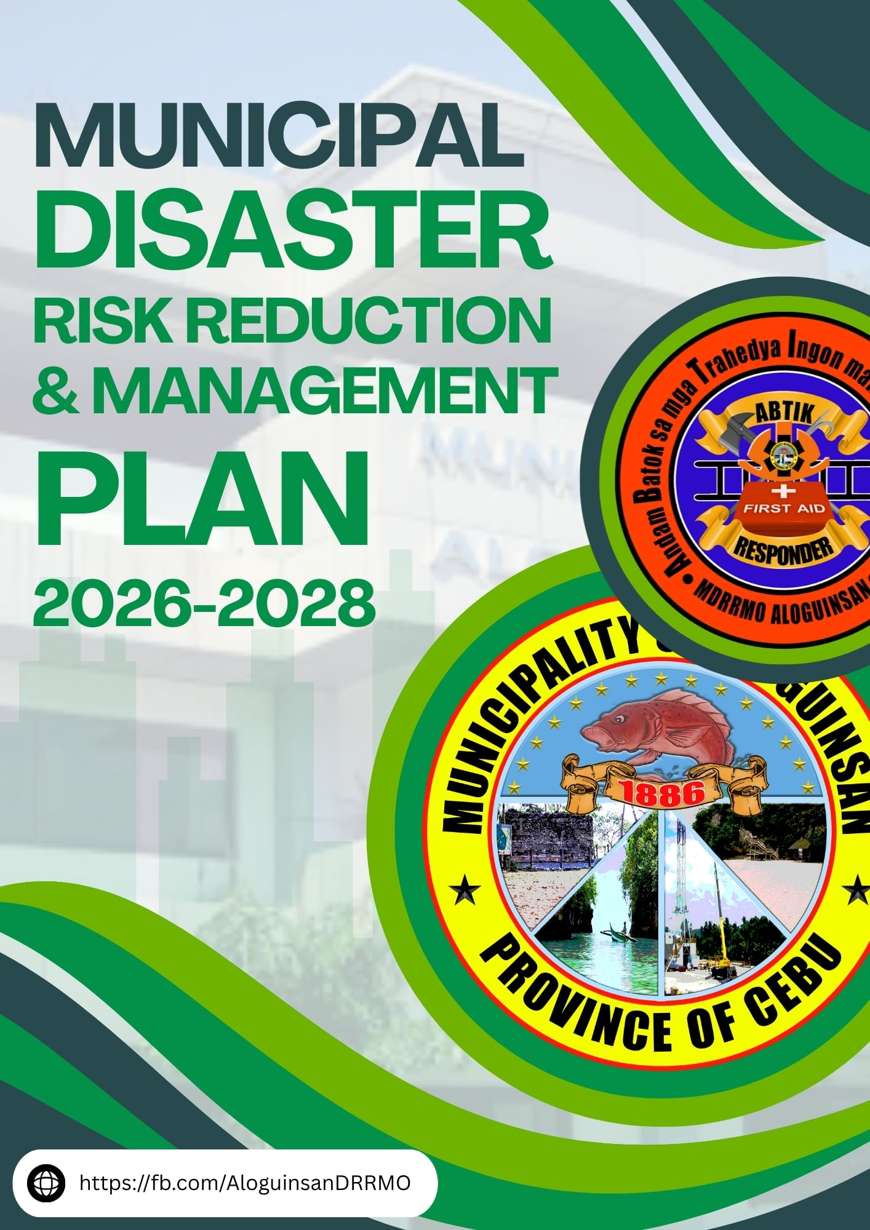

# **TABLE OF CONTENTS**

**HISTORY ---------------------------------------------------------------------------------------------------------- 1**

MDRRMP Cover ---------------------------------------------------------------------------------------------- 1

The Founding -------------------------------------------------------------------------------------------------- 2

The Municipal Seal ------------------------------------------------------------------------------------------- 2

**Resolution Adopting the Local DRRM Plan ----------------------------------------------------- 6**

Ordinances ------------------------------------------------------------------------------------------------- 6-18

**message from lce ------------------------------------------------------------------------------------------ 19**

Message from Mayor --------------------------------------------------------------------------------------- 19

**existing drrm-cca related issuances ------------------------------------------------------------- 20**

RA10121 -------------------------------------------------------------------------------------------------------- 20

GLOBAL ------------------------------------------------------------------------------------------------------- 20

Sendai Framework for Disaster Risk Reduction 2015-2030 ---------------------------------- 20

Paris Agreement 2015 on Climate Change ------------------------------------------------------- 20

United Nations Sustainable Development Goals ----------------------------------------------- 21

New Urban Agenda ------------------------------------------------------------------------------------ 21

International Health Regulations ------------------------------------------------------------------- 21

IASC Operational Guidelines on the Protection of Persons in Situations of Disasters - 21

REGIONAL ----------------------------------------------------------------------------------------------------- 22

Asia Regional Plan for Implementation of the Sendai Framework for Disaster Risk Reduction 2015-2030 ----------------------- 22

ASEAN Agreement on Disaster Management and Emergency Response ----------------- 22

Declaration on Institutionalizing the Resilience of ASEAN and its Communities and Peoples to Disasters and Climate Change ---------------- 22

Asia-Pacific Economic Cooperation Disaster Risk Reduction Framework ---------------- 23

NATIONAL ---------------------------------------------------------------------------------------------------- 23

NDRRMP 2020-2030 ----------------------------------------------------------------------------------- 23

Ambisyon Natin 2040 ---------------------------------------------------------------------------------- 23

Philippine Development Plan 2017-2022 --------------------------------------------------------- 24

National Climate Change Action Plan -------------------------------------------------------------- 24

National Framework Strategy on Climate Change 2010-2022 ------------------------------- 25

National Security Strategy ---------------------------------------------------------------------------- 25

Children’s Emergency Relief and Protection Act -------------------------------------------- 25-26

**Acronyms and Abbreviations -------------------------------------------------------------------------- 27**

Acronyms and Abbreviations --------------------------------------------------------------------------- 27-28

**Definition of Terms ----------------------------------------------------------------------------------------- 29**

Definition of Terms ---------------------------------------------------------------------------------------- 29-33

**Executive Summary ------------------------------------------------------------------------------------------ 34**

Executive Summary ---------------------------------------------------------------------------------------- 34-36

**Ecological Profile ---------------------------------------------------------------------------------------- 37-38**

Population and Social Services ------------------------------------------------------------------------------ 39

Health ---------------------------------------------------------------------------------------------------------- 40-41

Burial Grounds -------------------------------------------------------------------------------------------------- 41

Education --------------------------------------------------------------------------------------------------------- 42

Housing ------------------------------------------------------------------------------------------------------------ 42

Recreation and Sports Facilities ------------------------------------------------------------------------------42

Protective Services ---------------------------------------------------------------------------------------------- 43

Crime Incidence ------------------------------------------------------------------------------------------------- 44

Fire Incidence ---------------------------------------------------------------------------------------------------- 44

Local Economy -------------------------------------------------------------------------------------------- 44

Agricultural Crops ----------------------------------------------------------------------------------------- 44

Livestock and Poultry -------------------------------------------------------------------------------------44

Fisheries ----------------------------------------------------------------------------------------------------- 45

Food Self-Sufficiency Assessment --------------------------------------------------------------------- 45

Agricultural Support Facilities -------------------------------------------------------------------------- 45

Manufacturing --------------------------------------------------------------------------------------------- 46

Construction ------------------------------------------------------------------------------------------------ 46

Mining and Quarrying ------------------------------------------------------------------------------------ 46

Electricity, Gas and Water ------------------------------------------------------------------------------- 46

Infrastructure and Physical Base ------------------------------------------------------------------ 46

Domestic Water Supply ----------------------------------------------------------------------------------- 47

Current Water Demand ----------------------------------------------------------------------------------- 47

Other Water Sources -------------------------------------------------------------------------------------- 48

Electric Power Supply ------------------------------------------------------------------------------------- 48

Missionary Areas ------------------------------------------------------------------------------------------- 49

Transport Facilities ----------------------------------------------------------------------------------------- 49

Communication Facilities --------------------------------------------------------------------------------- 50

Waste Disposal System ------------------------------------------------------------------------------------ 50

Port Facilities ------------------------------------------------------------------------------------------------- 51

Municipal Cemetery ---------------------------------------------------------------------------------------- 51

Public Market ------------------------------------------------------------------------------------------------ 51

Environmental Management and Natural Resources ------------------------------------- 51

Soil -------------------------------------------------------------------------------------------------------------- 51

Land Resources ---------------------------------------------------------------------------------------------- 52

Existing Land and Water Use ----------------------------------------------------------------------------- 53

Mineral Resources ------------------------------------------------------------------------------------------ 53

Coastal Resources ------------------------------------------------------------------------------------------- 54

Seagrass Communities ------------------------------------------------------------------------------------- 54

Mangrove Forests ------------------------------------------------------------------------------------------- 55

Reef Fish Communities ------------------------------------------------------------------------------------ 55

Fresh Water Resources ------------------------------------------------------------------------------------ 56

**Institutional ------------------------------------------------------------------------------------------------------- 56**

The Local Disaster Risk Reduction and Management Council -------------------------------------- 56-57

The Local Disaster Risk Reduction and Management Office ---------------------------------------- 58-60

**Risk Profile ----------------------------------------------------------------------------------------------------------- 61**

All hazards ------------------------------------------------------------------------------------------------------------ 61

Flooding --------------------------------------------------------------------------------------------------------------- 62

Landslide -------------------------------------------------------------------------------------------------------------- 63

Storm Surge ---------------------------------------------------------------------------------------------------------- 64

Vulnerability, Capacity and Exposure ---------------------------------------------------------------- 65

Landslide --------------------------------------------------------------------------------------------------- 65-67

Flood ------------------------------------------------------------------------------------------------------------ 67

Storm Surge --------------------------------------------------------------------------------------------------- 68

**Situational Analysis --------------------------------------------------------------------------------------------- 69**

Disaster Prevention and Mitigation ---------------------------------------------------------------------------- 69

Disaster Preparedness ----------------------------------------------------------------------------------------- 70-71

Disaster Response and Early Recovery ----------------------------------------------------------------------- 72

Disaster Rehabilitation and Recovery ------------------------------------------------------------------------- 73

**Thematic Area Plan ---------------------------------------------------------------------------------------------- 74**

The Four Thematic Areas ----------------------------------------------------------------------------------------- 74

The Updated National Disaster Risk Reduction and Management Framework --------------------- 75

Disaster Prevention and Mitigation ------------------------------------------------------------------------ 76-79

Disaster Preparedness ----------------------------------------------------------------------------------------- 80-83

Disaster Response and Early Recovery -------------------------------------------------------------------- 84-87

Disaster Rehabilitation and Recovery ---------------------------------------------------------------------- 88-90

**Monitoring and Evaluation -------------------------------------------------------------------------------- 91**

Prevention and Mitigation ----------------------------------------------------------------------------------- 91-92

Preparedness ---------------------------------------------------------------------------------------------------- 93-95

Response and Early Recovery ------------------------------------------------------------------------------- 96-97

Rehabilitation and Recovery -------------------------------------------------------------------------------- 98-99

**Annexes -------------------------------------------------------------------------------------------------------------- 100**

Contents ------------------------------------------------------------------------------------------------------------- 100

**References ---------------------------------------------------------------------------------------------------------- 101**

Contents ------------------------------------------------------------------------------------------------------------- 101

**Resolution Adopting the LDRRMP**

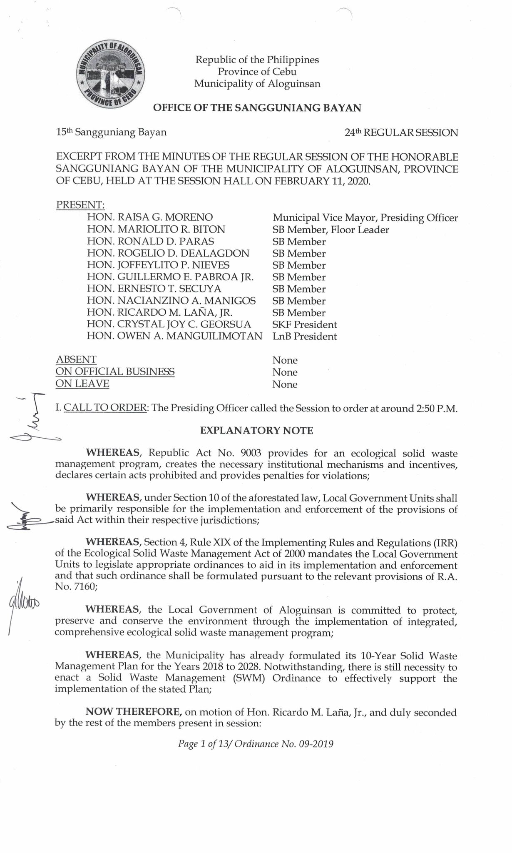

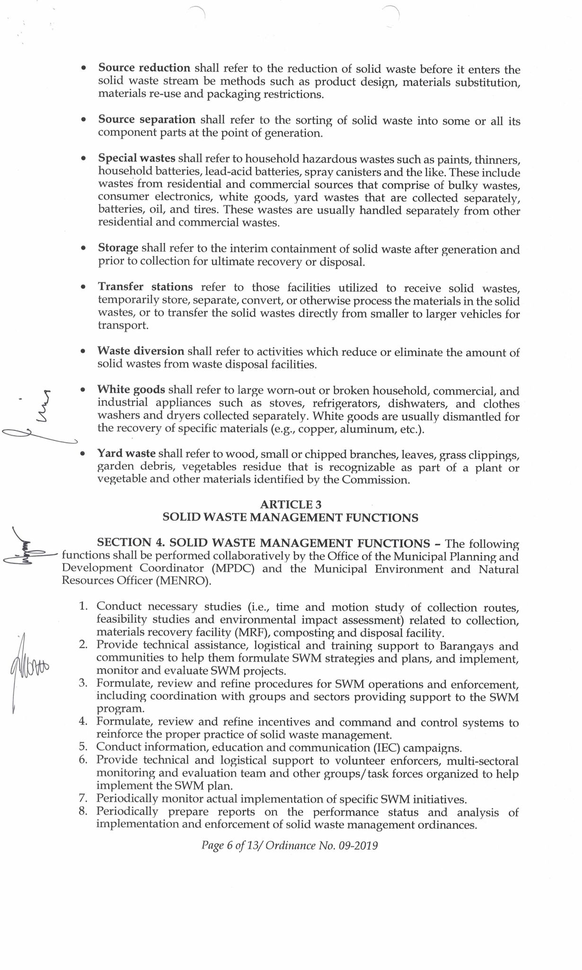

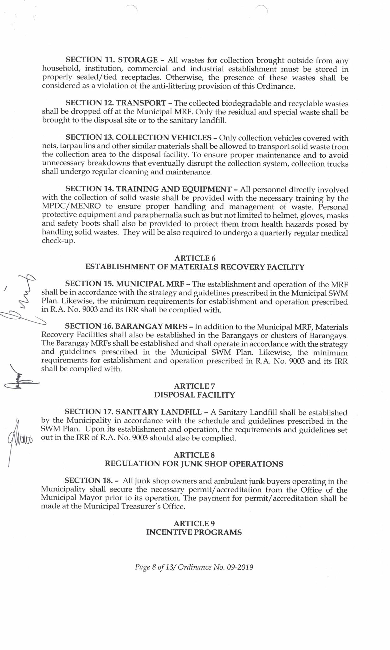

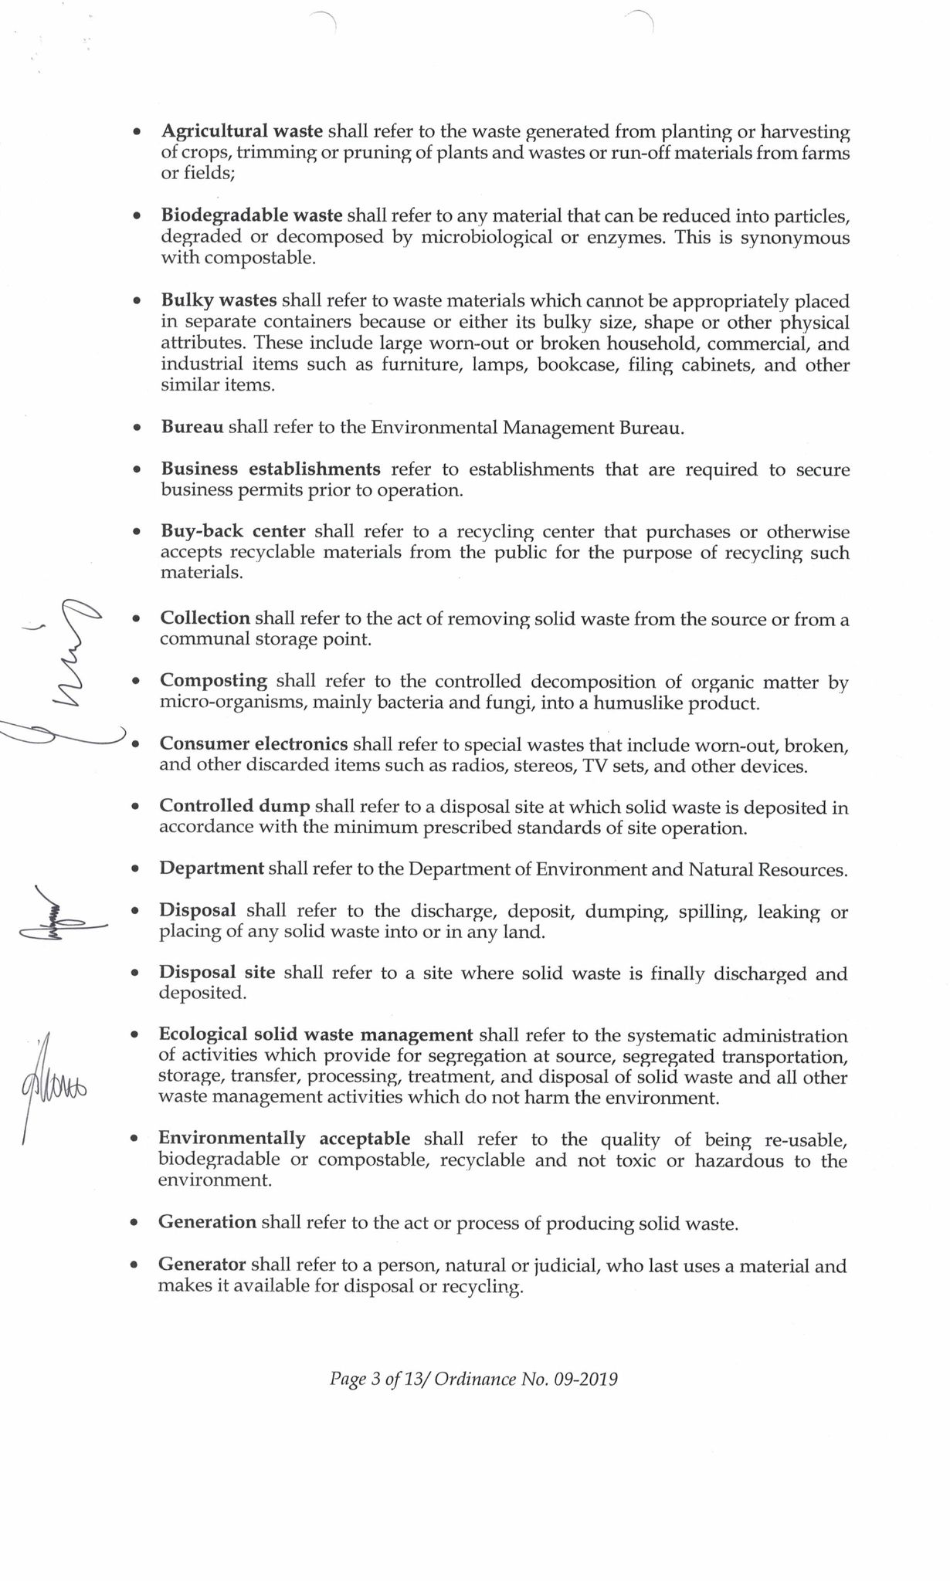

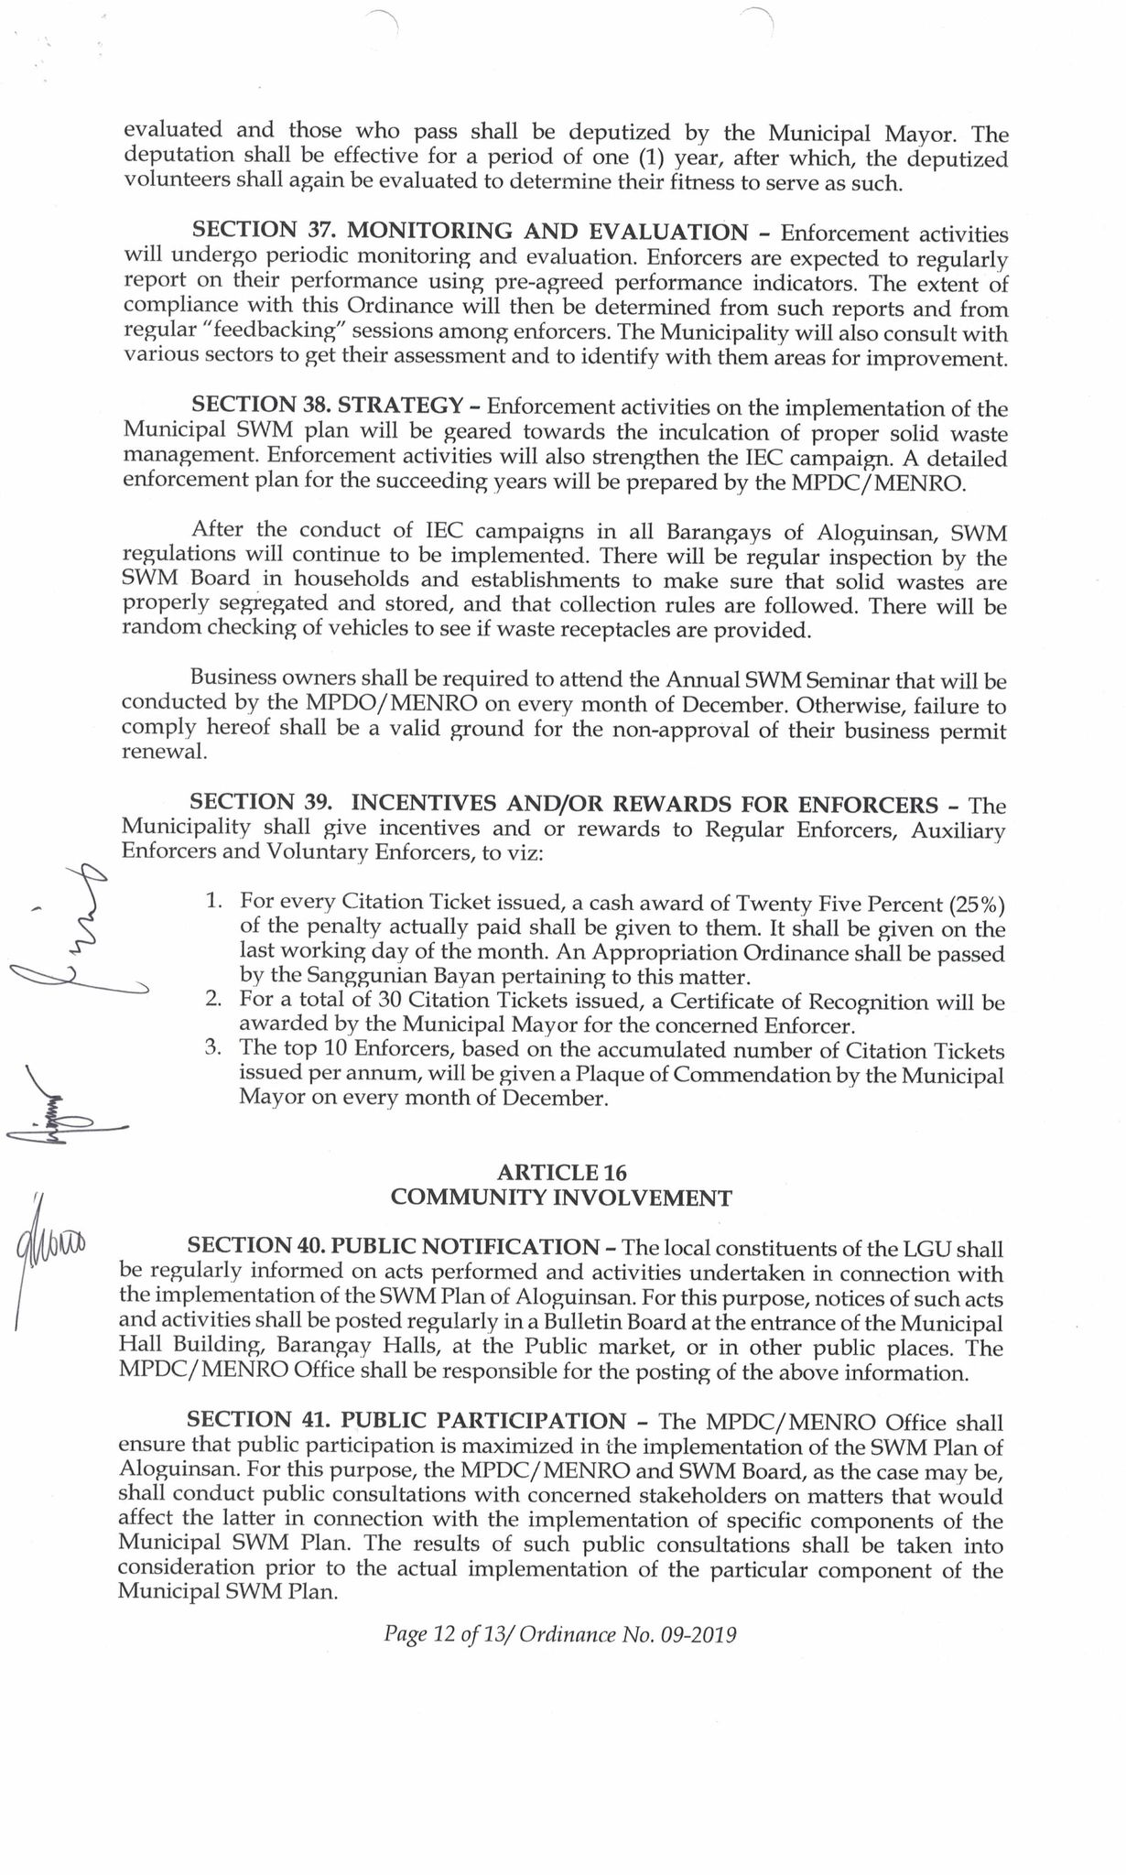

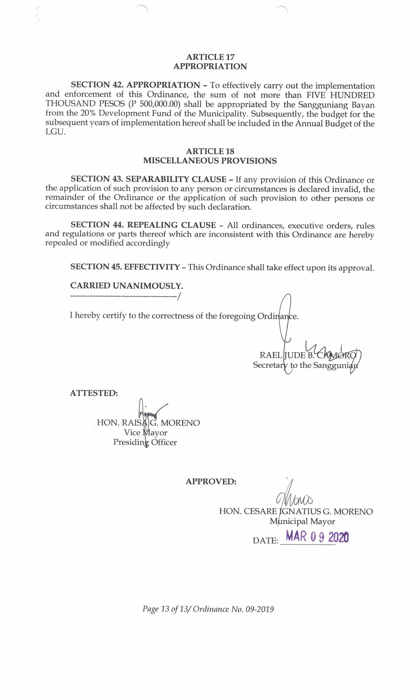

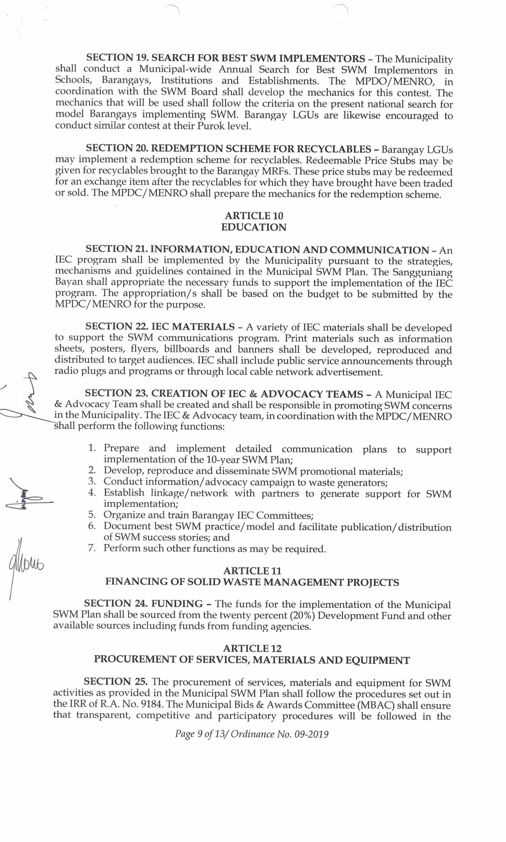

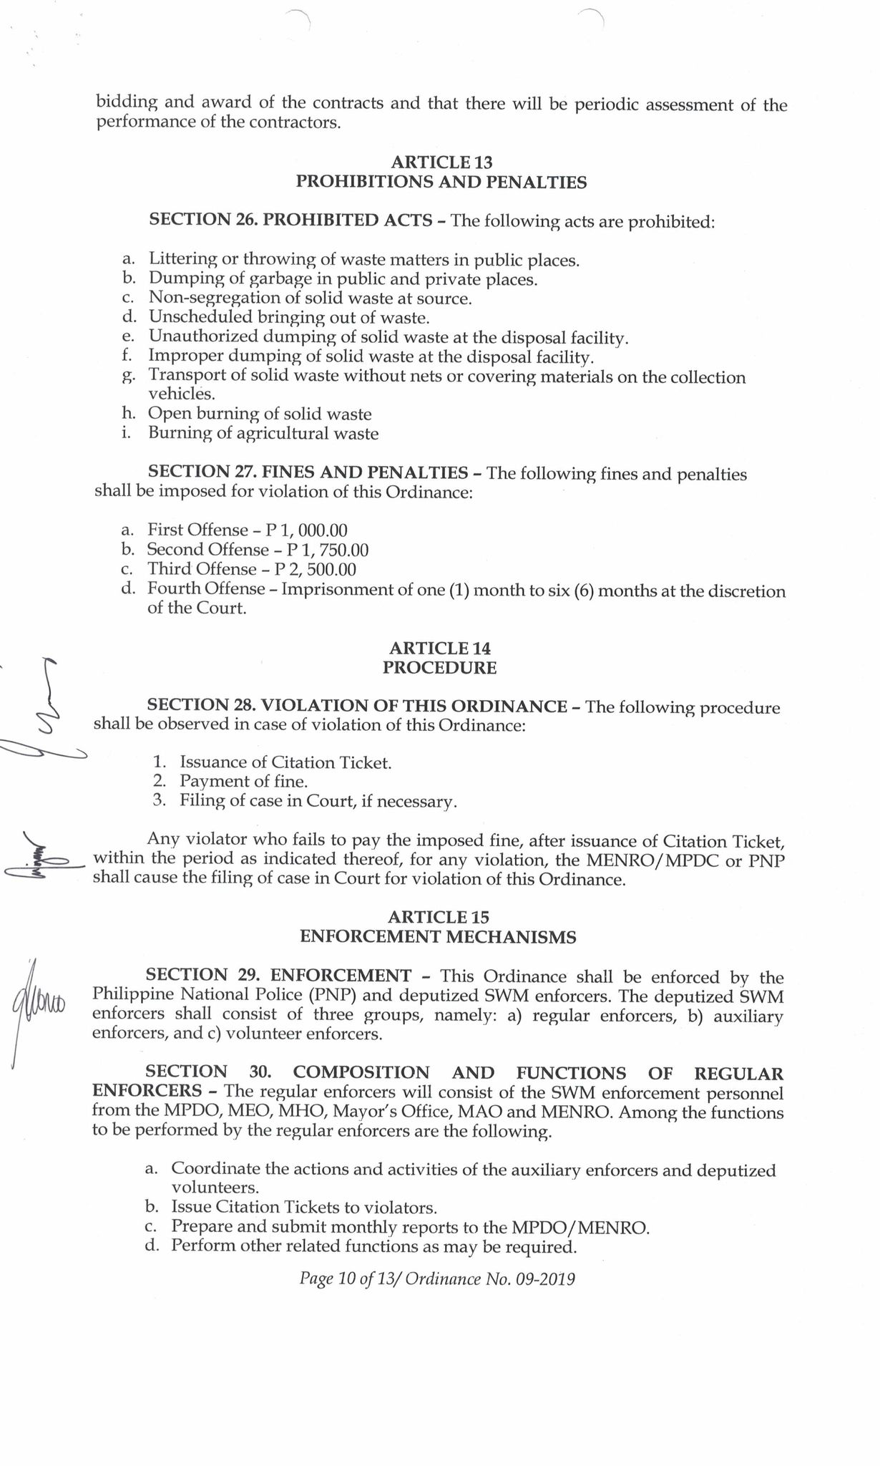

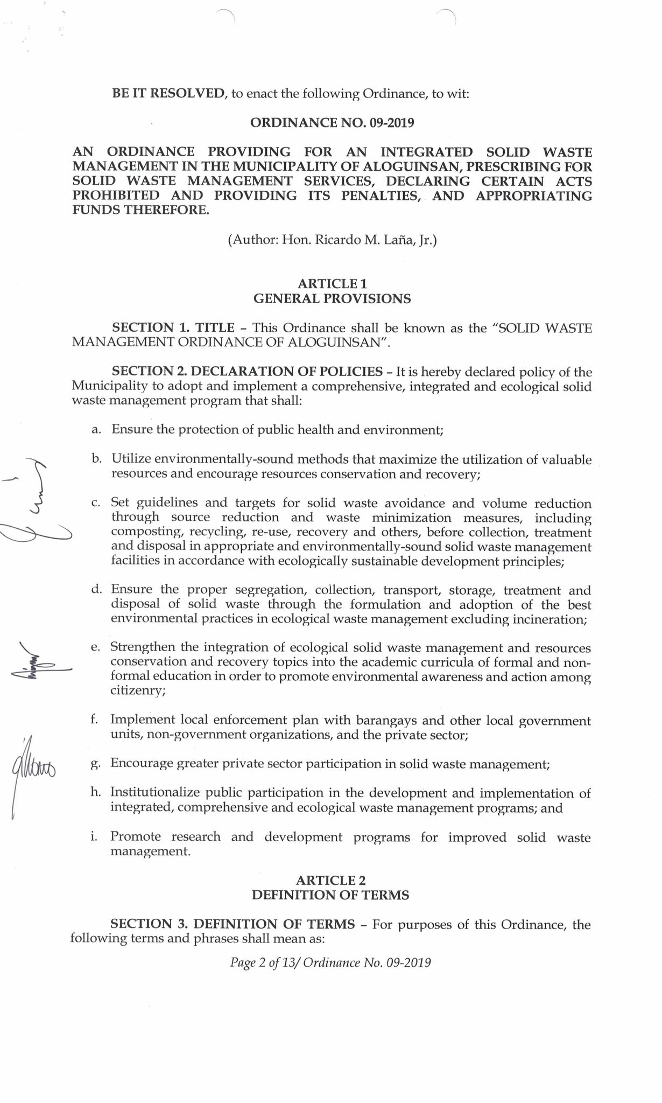

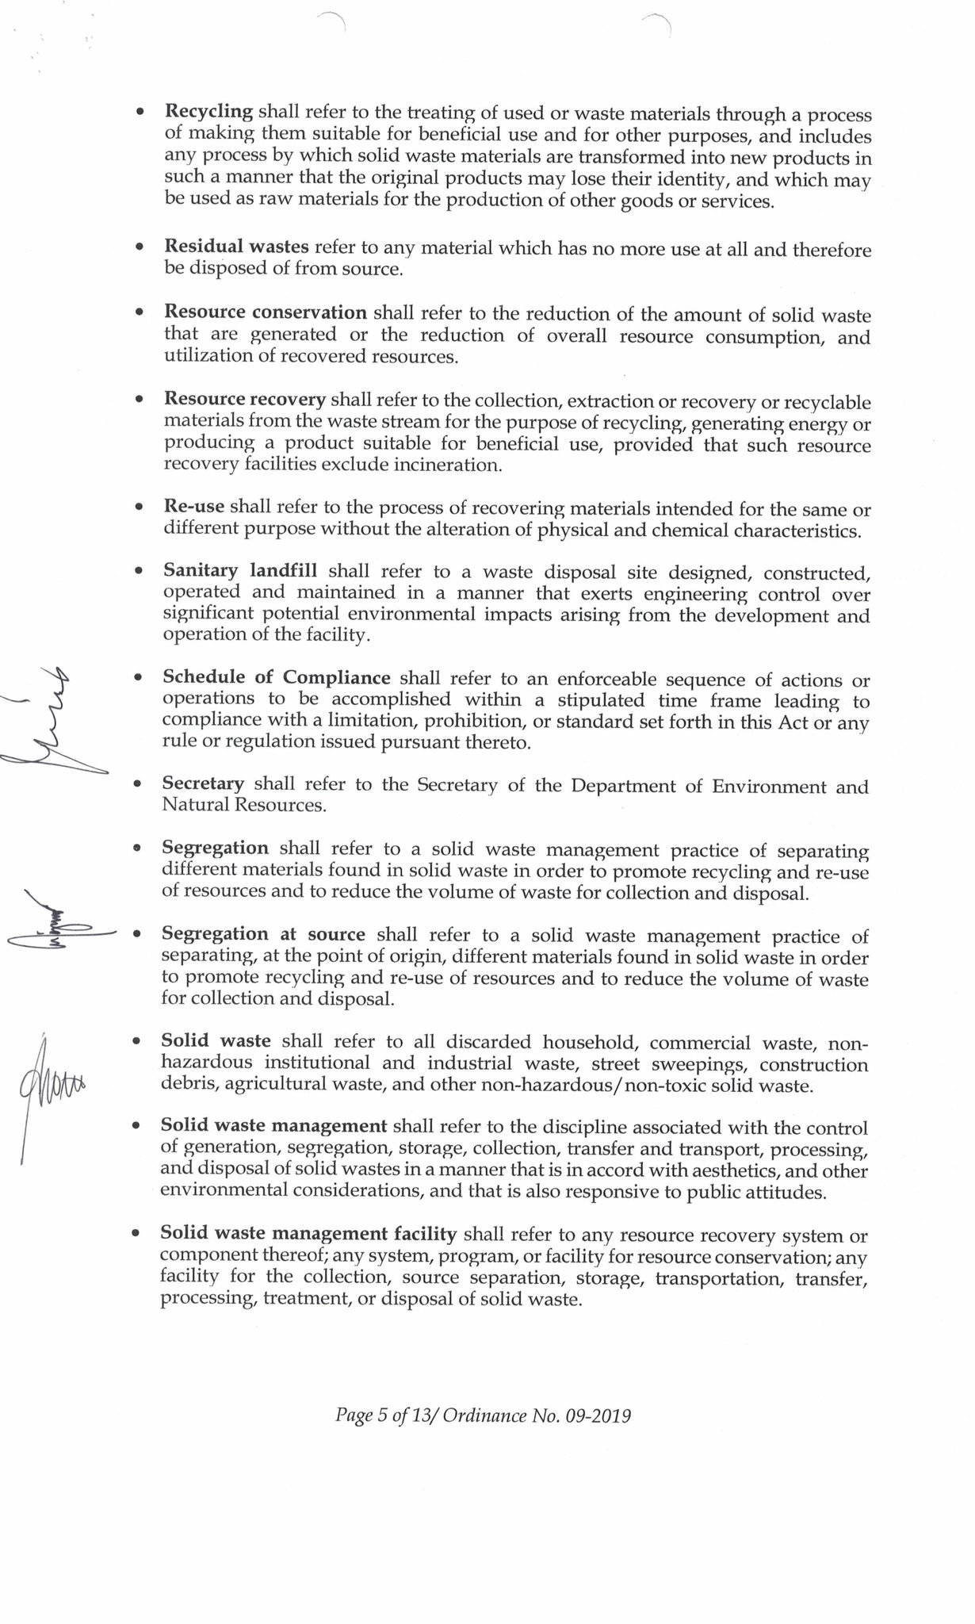

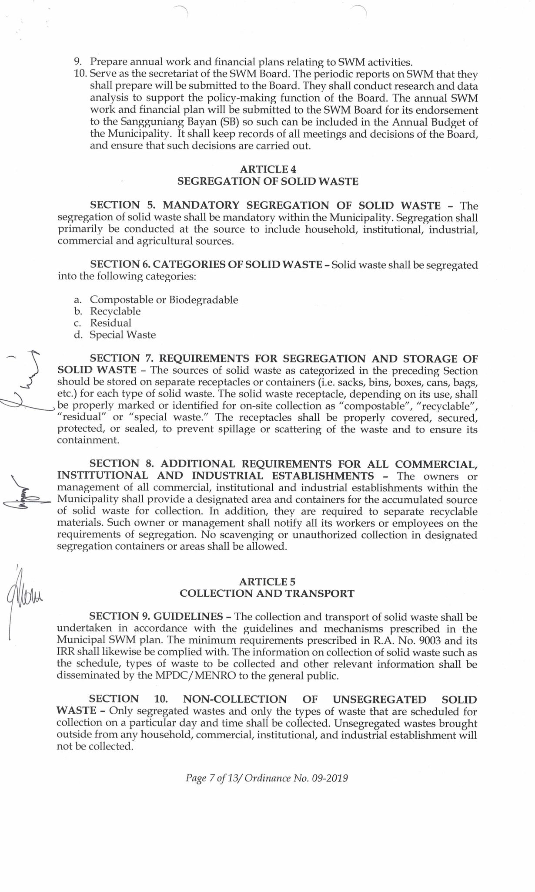

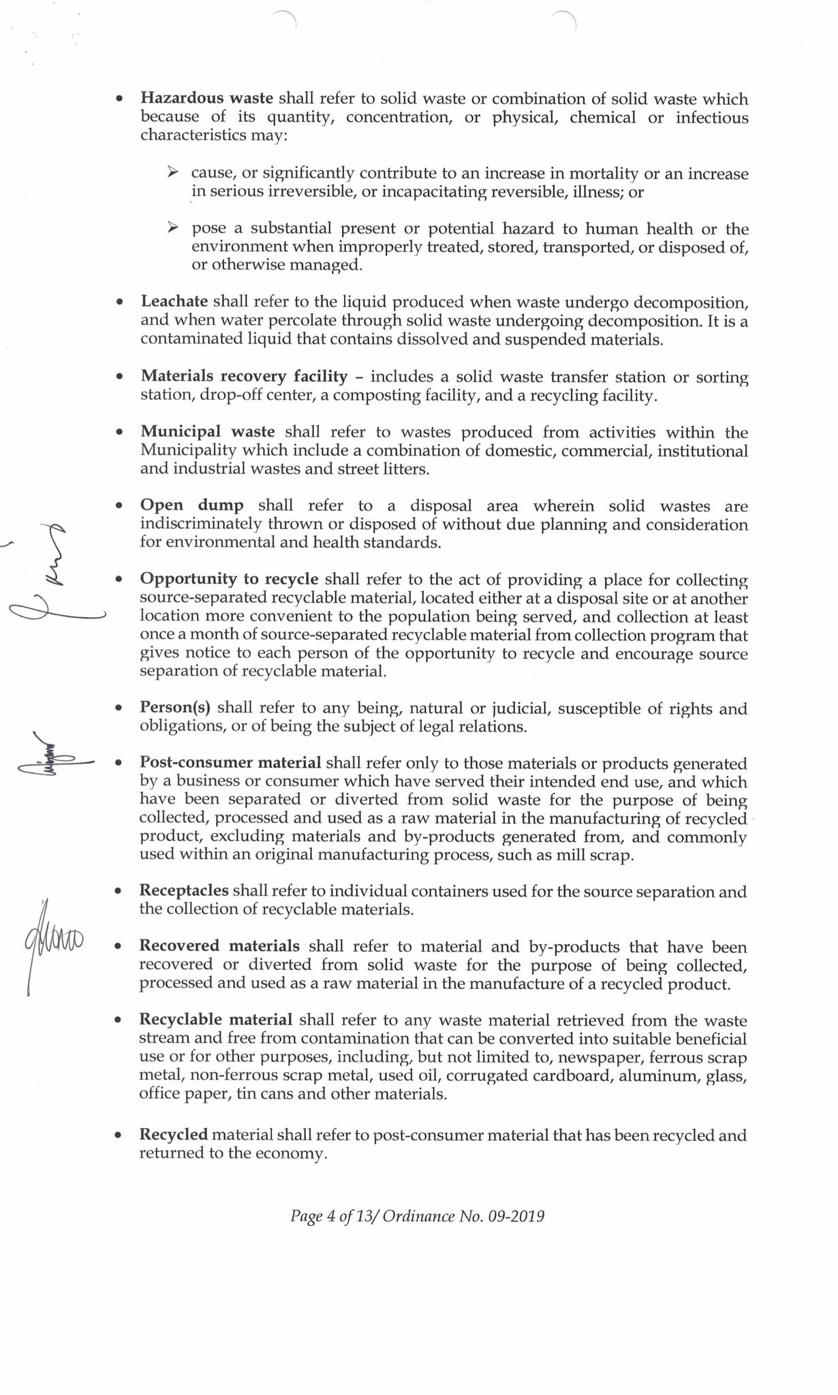

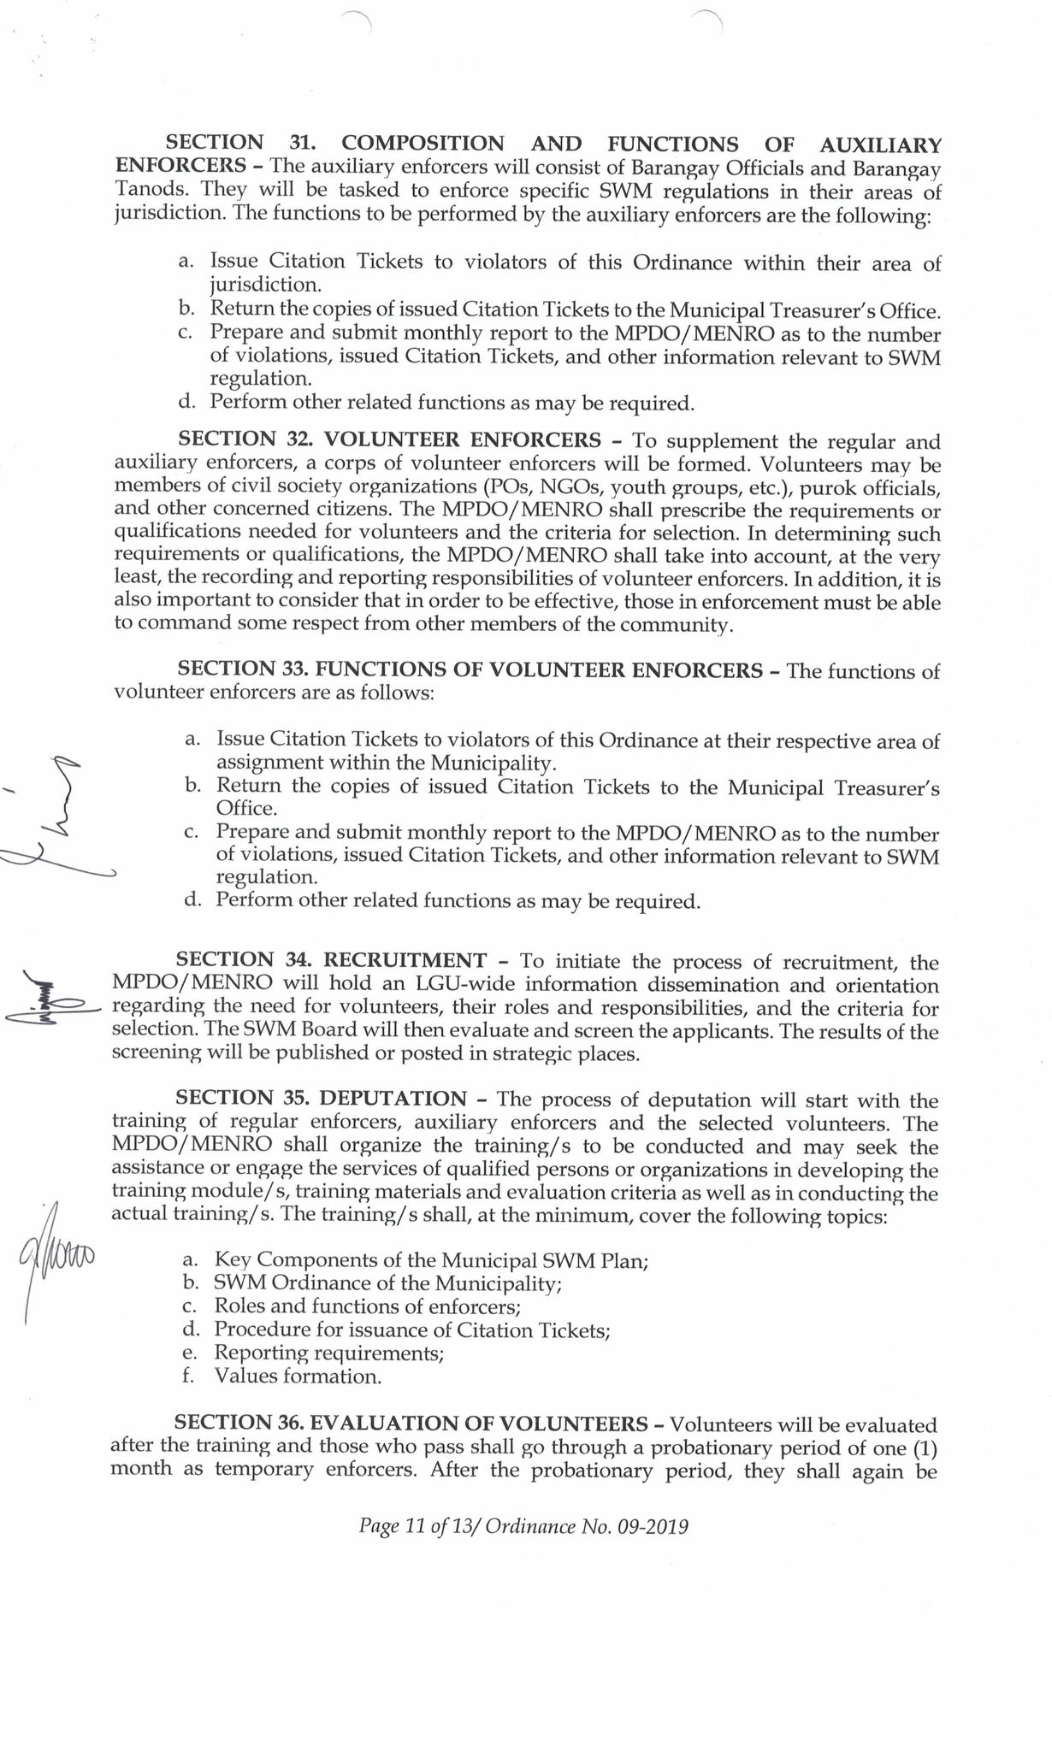

**Message from the Local Chief Executive**

**EXISTING DRRM-CCA-RELATED POLICIES/GUIDELINES/RESOLUTION**

**RA10121**

“The Philippine Disaster Risk Management Act of 2010: An Act Strengthening the Philippine Disaster Risk Reduction and Management System, providing for the National Disaster Risk Reduction and Management Framework, Institutionalizing the National Disaster Risk Reduction and Management Plan, Appropriating Funds Therefor and for Other Purposes” was passed into law in May 27, 2010. It serves as a legal and institutional basis to develop a framework and roll out resources that will integrate the national government, local government units, and other stakeholders into building proactive communities against disasters.

**Global**

**Sendai Framework for Disaster Risk Reduction 2015-2030**

It was adopted at the Third United Nations World Conference on Disaster Risk Reduction for concise, focused, forward-looking, and action-oriented post 2015 framework for disaster risk reduction. It is a 15-year, voluntary, non-binding agreement recognizing the primary role of the State in reducing disaster risk in partnership with the local government, private sectors, and other stakeholders. It aims to have a *‘substantial reduction of disaster risk and losses in lives, livelihoods, and health, and in the economic, social, physical, cultural, and environmental assets of persons, businesses, communities, and countries.’’*

Its priority areas are: (1) understanding disaster risk, (2) strengthening disaster risk governance to manage disaster risk, (3) investing in disaster risk reduction for resilience, (4) enhancing disaster preparedness for effective response and to “Build Back Better” in recovery, rehabilitation, and reconstruction.

**Paris Agreement 2015 on Climate Change**

It is the first-ever universal and legally-binding climate deal committing nearly every country on lowering greenhouse gas emissions to reduce global warming. In the Paris conference, governments agreed to reduce emissions, set more ambitious targets, and track progress to long term-goals with utmost transparency. It was also agreed to strengthen society’s ability to deal with the impacts of climate change and provide support for adaptation to developing countries. EU and other developed countries pledged support for developing countries in reducing emissions and building resilience against climate change.

**United Nations Sustainable Development Goals**

The SDGs, adopted by all United Nations Member States in 2015, provide a shared blueprint for peace and prosperity for people and the planet, now and into the future. At its heart are the 17 Sustainable Development Goals (SDGs), which are urgent calls for action by all countries – developed and developing – in a global partnership. They recognize that ending poverty and other deprivations must go hand-in-hand with strategies that improve health and education, reduce inequality, and spur economic growth –all while tackling climate change and working to preserve oceans and forests.

**New Urban Agenda**

Adopted at the United Nations Conference on Housing and Sustainable Urban Development (Habitat III) in 2016, the New Urban Agenda (NUA) provides a standard guidance to nations on how they will respond to the challenges and demands of rapid urbanization. It outlines the commitments of countries around the globe to achieve sustainable urban development in the next 20 years. In the NUA, leaders have committed to: (1) Provide basic services for all citizens; (2) Ensure that all citizens have access to equal opportunities and face no discrimination; (3) Promote measures that support cleaner cities; (4) Strengthen resilience in cities to reduce the risk and the impact of disasters; (5) Take action to address climate change by reducing their greenhouse gas emissions; (6) Fully respect the rights of refugees, migrants and internally displaced persons regardless of their migration status; (7) Improve connectivity and support innovative and green initiatives; and (8) Promote safe, accessible and green public spaces.

**International Health Regulations**

The International Health Regulations (IHR) 2005 is an agreement between 196 countries that comprise all Member States of the World Health Organization (WHO). It aims to ensure and promote global health security. Under the IHR, nations agreed to strengthen their capacities to detect, assess, and report heath events of public concern. The IHR specifically intends to “*prevent, protect against, control and provide a public health response to the international spread of disease inways that are commensurate with and restricted to public health risks, and which avoid unnecessaryinterference with international traffic and trade*.”

**IASC Operational Guidelines on the Protection of Persons in Situations of Disasters**

The Operational Guidelines ensure that disaster relief and recovery efforts are implemented within a framework that protects and furthers human rights of affected persons. It provides key principles which should guide humanitarian action in situations of disasters including protection of rights related to (i) protection of life, security and physical integrity, and the protection of family ties in the context of evacuations, (ii) the provision of food, health, shelter, and education, (iii) housing, land and property; and livelihoods, and (iv) documentation, free movement in the context of durable solutions for internally displaced persons, re-establishment of family ties, expression and opinion, and elections. These are accompanied by activities that aim to (i) prevent or stop harm; (ii) ensure that affected persons have access to relevant goods, services and opportunities; (iii) ensure that affected persons can claim their rights; and (iv) avoid or combat discrimination.

**Regional**

**Asia Regional Plan for Implementation of the Sendai Framework for Disaster Risk Reduction 2015-2030**

The Asia Regional Plan is one of the key outcome documents of the Asian Ministerial Conference on Disaster Risk Reduction (AMCDRR) in 2016 in New Delhi, India. It seeks to provide a platform to facilitate collaboration among countries in Asia on building resilience by providing a policy direction, a long-term road map, and a two-year action plan. The regional plan intends to guide the national implementation of the SFDRR by identifying priorities at regional activities to support national and local actions, enhance exchange of good practice, knowledge and information among governments and stakeholders, in addition to intensifying regional cooperation to support the implementation of the SFDRR.

**ASEAN Agreement on Disaster Management and Emergency Response**

The ASEAN Agreement on Disaster Management and Emergency Response (AADMER) is a legally binding agreement made among the ASEAN member States in 2009. It provides a venue for cooperation in enhancing DRR and CCA efforts at the regional level since 2009. At present, the AADMER work programme is being updated. To continuously realize its aims of reducing disaster losses and facilitate partnerships to respond jointly to disasters, the AADMER Work Programme 2016-2020 was crafted. The said Work Programme revolves around eight (8) priority programs, namely: (1) Risk Aware ASEAN Community; (2) Building Safe ASEAN Infrastructures and Essential Services; (3) Advance a Disaster Resilient and Climate Adaptive ASEAN Community; (4) Protecting Economic and Social Gains of ASEAN Community Integration Through Risk Transfer and Social Protection; (5) Transforming Mechanisms for ASEAN’s Leadership in Response; (6) Enhanced Capacities for One ASEAN One Response; (7) ASEAN Resilient Recovery; and (8) ASEAN Leadership for Excellence and Innovation in Disaster Management.

**Declaration on Institutionalizing the Resilience of ASEAN and its Communities and Peoples to Disasters and Climate Change**

Adopted during the 26th ASEAN Summit held in 2015, the declaration outlines the commitments of the Philippines and other ASEAN member countries to the implementation of various post-2015 development frameworks such as the SFDRR, Paris Agreement, and Sustainable Development Goals. The declaration emphasizes their pledge to play an active and responsible role at the regional and international scales in implementing efforts to simultaneously and collaboratively address the interlocking issues of DRR and CCA towards promoting development that is transformative, inclusive, adaptive and sustainable.

**Asia-Pacific Economic Cooperation Disaster Risk Reduction Framework**

Developed in 2015, the APEC DRR Framework seeks to contribute to adaptive and disaster resilient Asia-Pacific economies that can support inclusive and sustainable development in the face of disasters and the “new normal”. This framework cuts across all areas of the APEC agenda, including agriculture; forestry; fisheries; trade and investments; energy; micro, small, and medium enterprises (MSMEs); infrastructure development; critical infrastructure resiliency; financial resiliency; human capital; health; gender; food security; science and technology; and ecological integrity.15 For the framework to work effectively, it emphasized the importance of an enabling environment anchored on community participation, disaster risk governance, disaster risk financing, innovations on Science and Technology, critical infrastructure resiliency, ecological integrity, and inclusiveness of women and vulnerable sectors. Further, it also underscored the significance of collaboration between the public and private sectors towards achieving disaster resilience.

**National**

**NDRRMP 2020-2030**

NDRRMP fulfills the requirement of RA 10121 which provides the legal basis for the plans, programs, and policies related to disasters. NDRRMP sets down the goals to be achieved by 2030 and the specific objectives, outcomes, outputs, and activities for each thematic area to realize these goals. NDRRMP is a road map of DRRM that is gender-responsive and rights-based. It serves as the mother plan of all the local disaster risk reduction and management plans institutionalizing DRRM policies, structures, coordination mechanism, and programs with continuing budget allocation on DRR. It also aims to mainstream DRRM and CCA to the development processes and plans. Capacity building should be competent and science-based, with continuous learning through knowledge enhancement and taking note of DRRM good practices on the ground. It also encompasses conflict resolution approaches to avoid human-induced disasters by mainstreaming DRRM into the peace process.

**Ambisyon Natin 2040**

Ambisyon Natin 2040 outlines the long-term vision and aspirations of the Filipino people for themselves and for the country. The crafting of the vision started in 2015 involving different stakeholders from the public and private sectors through focus group discussion and conduct of national survey. Ambisyon 2040 is seen as an anchor for development planning that will steer the path Filipinos towards a stable and comfortable life.

*Ambisyon Natin* 2040 envisions that all Filipinos experience a strongly rooted, comfortable, and secure life (*Matatag, Maginhawa at PanatagnaBuhay*) by 2040. With this vision, Filipinos are hoped to demonstrate close family ties and strong sense of community; Filipinos are free from poverty and hunger; Filipinos live long and enjoy a comfortable life; and Filipinos are protected by a clean and fair government.

**Philippine Development Plan 2017-2022**

The Philippine Development Plan (PDP) 2017-2022 is the first medium-term plan anchored on AmBisyon Natin 2040, which is supposed to represent the vision and aspirations of the Filipino people for a matatag, maginhawa at panatagnabuhay (strongly-rooted, comfortable and secure life), in the next 25 years. Specifically, the updated PDP seeks to have “a healthy and resilient Philippines.”

The PDP recognizes that disasters and climate risks destroy development gains, thus, making investments in vulnerability reduction and resilience building are imperative. In response to this, the PDP espouses for a national spatial strategy (NSS) which provides the basis for policies on urban development, infrastructure development, disaster mitigation, and environmental resource protection and conservation. Said strategy seeks to make vulnerability reduction a fundamental part of development. Vulnerability reduction involves instituting prevention and mitigation measures to avoid or reduce the impact of climate change and disasters on the community.16 Among the concrete DRRM and CCA-related strategies identified in the PDP are: (1) implement a convergence approach to help the poor and vulnerable become self-sufficient and self-reliant; (2) accelerate construction of disaster- and climate-resilient small-scale irrigation systems and retrofit existing ones; (3) development of climate and disaster-responsive technologies and innovations in the agriculture and fisheries sector; (4) roll out of climate vulnerability assessment and climate/disaster risk assessment nationwide; (5) develop facilities for adaptation including risk transfer mechanisms (RTM); (6) provide adequate transition houses and livelihood opportunities for disaster victims during early rehabilitation and recovery period; (7) provide adequate mental health and psychosocial support (MHPSS); (8) capacitate program and local planners on anticipatory planning (multiscenario analysis) or future-oriented culture; (9) mandate establishment of women-, adolescent-, and child-friendly spaces in all evacuation centers in the country; (10) passage of the Evacuation Center Act; and, (11) enhance the capability of the security sector in humanitarian assistance and disaster response.

**National Climate Change Action Plan**

Apart from the PDP, the NDRRMP needs to be updated to be consistent with the National Climate Change Action Plan (NCCAP). The NCCAP details the long-term agenda of the country for climate change adaptation and mitigation covering the period of 2011 to 2028. The NCCAP’s strategic priorities include (1) food security; (2) water efficiency; (3) ecosystem and environmental stability; (4) human security; (5) climate-smart industries and services; (6) sustainable energy; and (7) knowledge and capacity development. The aforementioned priorities are fundamental in realizing the NCCAP’s ultimate goal which is to “build the adaptive capacities of women and men in their communities, increase the resilience of vulnerable sectors and natural ecosystems to climate change and optimize mitigation opportunities towards gender-responsive and rights-based sustainable development.

**National Framework Strategy on Climate Change 2010-2022**

With the passage of the Climate Change Act (RA 9729) in 2009, the National Framework Strategy on Climate Change (NFSCC) was established to guide the country in developing programs and policies in response to climate change. The main goal of the framework strategy is to build the adaptive capacity of communities and increase the resilience of natural ecosystems to climate change and optimize mitigation opportunities towards sustainable development. The NFSCC envisions a climate risk-resilient Philippines with healthy, safe, prosperous and self-reliant communities, and thriving and productive ecosystems Further, it also highlights the mutually beneficial relationship between climate change mitigation and adaptation. The NFSCC serves as the framework for the development of local and national climate change action plans.

**National Security Strategy**

The *National Security Policy 2017-2022: For Change and Well-Being of the Filipino People* served as the basis in developing the National Security Strategy (NSS). The NSS describes the ways and means to attain the national security vision for “a safe and secure Philippines, at peace with itself and its neighbors, where its citizens are allowed to reach their full potential through the promotion of social justice and harmony, political stability, sound environmental management, and economic progress.” It may not be stated explicitly but the NSS is built around protecting human security and elaborates on the two elements: freedom from fear and freedom from want. The NSS outlines the 12-point national security goals which links to DRRM through consequence*\* management including the following: (1) Guarantee public safety and achieve good governance; (2)Mitigate the impact of health related threats; (3) Develop a dynamic, inclusive, and sustainable economy; (4) Achieve food and water security; (5) Safeguard and preserve national sovereignty and territorial integrity; (6) Heighten consciousness and pride on Filipino heritage, culture and values;(7) Promote human and ecological security; (8) Achieve energy security; (9) Ensure maritime and airspace security; (10) Strengthen international relations; (11) Provide strong cyber infrastructure and cyber security; and (12) Improve vital transportation infrastructure and port security.18These goals serve as guides for concerned government agencies and departments in developing their strategic actions to achieve lasting peace and prosperity across the country.

**Children’s Emergency Relief and Protection Act**

Enacted in 2016, the Children’s Emergency Relief and Protection Act, otherwise known as RA 10821, mandates the protection of the fundamental rights of children before, during, and after disasters and other emergency situations. The law obligates the national and local government to implement and maintain a comprehensive emergency program to prioritize the survival and protection of children, pregnant, and lactating mothers during disasters and emergencies. Through the leadership of the DSWD, the Comprehensive Emergency Program for Children (CEPC) was crafted and has eight (8) components which include the following: (1) establishment of evacuation centers; (2) establishment of child and women-friendly transitional shelters; (3) immediate delivery of basic necessities and services; (4) stronger measures to ensure safety and security of affected children; (5) delivery of health, medical and nutritional services; (6) plan of action for prompt resumption of educational services for children; (7) establishment of child-friendly spaces in evacuation centers and transitional sites; and (8) promotion of children’s rights during disaster and emergency situations.

**ACRONYMS AND ABBREVIATIONS**

ABTIK Andam Batok sa mga Trahedya Ingon man sa mga Katalagman

BDRRMC Barangay Disaster Risk Reduction and Management Committee

BDRRMP Barangay Disaster Risk Reduction and Management Plan

CBMS Community Based Monitoring System

CC Climate Change

CCA Climate Change Adaptation

CDRA Climate and Disaster Risk Assessment

CCVA Climate Change Vulnerability Assessment

CDP Comprehensive Development Plan

CLUP Comprehensive Land Use Plan

CSO Civil Society Organizations

DANA Damage Analysis and Needs Assessment

DENR Department of Environment and Natural Resources

DRR Disaster Risk Reduction

DRR/CCA Disaster Risk Reduction/ Climate Change Adaptation

DRRM City Disaster Risk Reduction and Management

DRRMC City Disaster Risk Reduction and Management Council

DRRMO Disaster Risk Reduction and Management Office

DRRMP Disaster Risk Reduction and Management Plan

ERT Emergency Response Team

EOC Emergency Operations Center

FLUP Forest Land Use Plan

ICS Incident Command System

LCCAP Local Climate Change Action Plan

LDC Local Development Council

LDRRMC Local Disaster Risk Reduction and Management Council

LDRRMF Local Disaster Risk Reduction and Management Fund

LDRRMO Local Disaster Risk Reduction and Management Officer

M&E Monitoring and Evaluation

MDRRMC Municipal Disaster Risk Reduction and Management Council

NDRRMC National Disaster Risk Reduction and Management Council

MDRRMP Municipal Disaster Risk Reduction and Management Plan

MENRO Municipal Environment and Natural Resources Office

MGB Mines and Geosciences Bureau

MPA Marine Protected Area

MSWDO Municipal Social Welfare and Development Office

NDRRMP National Disaster Risk Reduction and Management Plan

OCD Office of Civil Defense

OVI Objectively Verifiable Indicators

PAGASA Philippine Atmospheric Geophysical and Astronomical Services Administration

PHIVOLCS Philippine Institute of Volcanology and Seismology

PPA Programs, Projects and Activities

PDNA Post Disaster Needs Assessment

PWD Persons with Disabilities

QRF Quick Response Fund

RDANA Rapid Damage Analysis Needs Assessment

RHU Rural Health Unit

SLR Sea Level Rise

SRR Search, Rescue and Retrieval

SWMP Solid Waste Management Plan

SWOC Strengths, Weaknesses, Opportunities and Challenges

TWG Technical Working Group

**DEFINITION OF TERMS**

**Adaptation** – the adjustment in natural or human systems in response to actual or expected climactic stimuli or their effects, which moderates harm or exploits beneficial opportunities.

**Adaptive Capacity** – refers to the ability of ecological, social or economic systems to adjust to climate change, variability and extremes, as well as moderate or offset potential damages, and take advantage of associated opportunities (IPCC 2007). It also implies the ability to anticipate hazard or perturbation (UNDP 2010). It determines whether the system absorbs changes without damage or whether these changes will lead to negative consequences.

**Capacity** – a combination of all strengths and resources available within the community, society or organization that can reduce the level of risk, or impacts of disaster. Capacity may include infrastructure and physical means, institutions, societal coping abilities, as well as social relationships, leadership and management, capacity may also be described as capability.

**Civil Society Organizations or “CSOs”**- non-state actors whose aims are neither to generate profits nor to seek governing power. CSOs unite people to advance shared goals and interests. They have the presence in public life expressing the interests and values of their members or others, and are based on ethical, cultural, scientific, religious or philanthropic considerations. CSOs include nongovernment organizations (NGOs), professional associations, foundations, independent research institutes, community-based organizations (CBOs), faith-based organizations, people’s organization social movements, and labor units.

Climate - The average of weather over at least a 30-year period. Note that the climate taken over different periods of time (30 years, 1,000 years) may be different. The old saying is that climate is what we expect and weather is what we get. (NOAA/CPC)

**Climate Change** – a change in climate that can be identified by changes in the mean/or variability of its properties and that properties and that persists for an extended period typically decades or longer, whether due to natural variability or as a result of human activity.

**Climate Risk** – refers to the product of climate and related hazards working over the vulnerability of human and natural ecosystems.

**Climate Variability** - refers to variations in climatic conditions (average, extreme events, among others) on time and space scales beyond individual weather events, but not persisting for extended periods (shorter term than climate change) (ADB 2005)

**Community – Based Disaster Risk Reduction and Management or “CBDRRM”** – a process of disaster risk reduction and management in which at risk communities are actively engaged in the identification, analysis, treatment, monitoring and evaluation of disaster risk in order to reduce their vulnerabilities and enhance their capacities, and where the people are at the heart of decision-making and implementation of disaster risk reduction and management activities.

**Complex Emergency** – a form of human – induced emergency in which the cause of the emergency as well as the assistance to the afflicted is complicated by intense level of political considerations.

**Contingency Planning** – a management process that analyzes specific potential events or emerging situations that might threaten society or the environment and establishes arrangements in advance to enable timely, effective and appropriate responses such events and situations.

**Disaster** – a serious disruption of the functioning of a community or a society involving widespread human, materials, economic or environmental losses and impacts, which exceeds the ability of affected community or society to cope using its own resources. Disasters are often described as a result of the combination of the exposure to a hazard: the conditions of vulnerability that are present; and insufficient capacity or measures to reduce or cope with the potential negative consequences. Disaster impacts may include loss of life, injury, disease and other negative effects of human, physical, mental, and social well-being, together with damage to property, destruction of assets, loss of services and economic disruption and environmental degradation.

**Disaster Mitigation** – the lessening or limitation of the adverse impacts of hazards and related disasters. Mitigation measures encompass engineering techniques and hazard – resistant construction as well as improved environmental policies and public awareness. It includes structural and non-structural measures undertaken to limit the adverse impact of natural hazards, environmental degradation and technological hazards and to ensure the ability of at-risk communities to address, vulnerabilities aimed at minimizing the impact of disasters. Such measures include, but are not limited to, hazard resistant construction and engineering works, the formulation and implementation of plans, programs, projects and activities, awareness raising, knowledge management, policies on land-use and resource management, as well as the enforcement of comprehensive land-use planning, planning and safety standards, and legislation.

**Disaster Preparedness** – the knowledge and capacities developed by governments, professional response and recovery organizations, communities and individuals to effectively anticipate, respond to, and to recover from, the impacts of likely, imminent or current hazard events r conditions. Preparedness action is carried out within the context of disaster risk reduction and management andaims to build the capacities needed to efficiently manage all types of emergencies and achieve orderly transitions from response to sustained recovery. Preparedness is based on a sound analysis of disaster risk and good linkages with early warning systems, and includes such activities as contingency planning, stockpiling of equipment and supplies, the development of arrangements for coordination, evacuation and public information and associated training and field exercises. These must be supported by formal institutional, legal and budgetary expenses.

**Disaster Prevention** – the outright avoidance of adverse impacts of hazards and related disasters. It expresses the concept and intention to completely avoid potential adverse impacts through action taken in advance such as construction of dams or embankments the eliminate flood risks, land-use regulations that do not permit any settlement in high-risk zones, and seismic engineering designs that ensure the survival and function of a critical building in any likely earthquake.

**Disaster/Climate Resilience** – refers to the ability of a system, community or society exposed to hazards to resist, absorb, accommodate, and recover from the effects of a hazard in a timely and efficient manner, including the preservation and restoration of its essential basic structures and functions (UNISDR 2009). Improved adaptation can help develop resiliency. Disaster Response - the provision of emergency services and public assistance during or immediately after a disaster in order to save lives reduces health impacts, ensure public safety and meet the basic subsistence needs of the people affected. Disaster response is predominantly focused on immediate and short-term needs and is sometimes called “disaster relief”.

**Disaster Response** - the provision of emergency services and public assistance during or immediately after a disaster in order to save lives, reduce health impacts, ensure public safety and meet the basic subsistence needs of the people affected. Disaster response is predominantly focused on immediate and short-term needs and is sometimes called "disaster relief'.

**Disaster Risk** – the potential disaster losses in lives, health status, livelihood, assets and services, which could occur to a particular community or a society over some specified future time period.

Disaster Risk Reduction – the concept and practice of reducing disaster risks through systematic efforts to analyze and manage the casual factors of disasters, including through reduced exposures to hazards, lessened vulnerability of people and poverty, wise management of land and the environment, and improved preparedness for adverse events.

**Disaster Risk Reduction and Management** – the systematic process of using administrative directives organizations, and operational skills and capacities to implement disaster strategies, policies and improved coping capacities in order to lessen the adverse impacts of hazards and the possibility of disaster. Prospective disaster risk reduction and management activities that address and seek to avoid the development of new or increased disaster risks, especially if risk reduction policies are not put in place.

Disaster Risk Reduction and Management Information System – a specialized database which contains, among other, information on disaster and their human material, economic and environmental impact, risk assessment and mapping and vulnerable groups.

**Early Warning System** – the set of capacities needed to generate and disseminate timely meaningful warning information to enable individuals, communities and organization threaten by a hazard toprepare and to act appropriate and in sufficient time to reduce the possibility of harm or loss. A people-centered early warning system necessarily comprises four (4) key elements: knowledge of the risks monitoring, analysis and forecasting of the hazards: communication or dissemination of alerts and warnings; and local capabilities to respond to the warnings received. The expression “end-to-end warning system” is also used to emphasize that warning systems need to span all steps from hazard detection to community response.

**Emergency** – unforeseen or sudden occurrence especially danger, demanding immediate action.

Emergency Management – the organization and management of resources and responsibilities for addressing all aspects of emergencies, in particular preparedness, response and initial recovery steps.

**Exposure** – the degree to which the element at risk are likely to experience hazard and events of different magnitudes. It refers to the nature and degree to which a system is exposed to significant climatic variations (IPCC). It depends on frequency, magnitude, intensity and duration of climate stressor, such as El Niño, La Niña, temperature rise, sea level rise, tropical cyclone and other extreme events. For example, an intensifying cyclone may lead to the increased risks of climate-induced hazards such as floods and landslides, and their impacts.

**Geographic Information System** – a database which contains, among others, geo-hazard assessments, information on climate change, and climate risk reduction and management.

**Hazard** – dangerous phenomenon, substance, human activity or condition that may cause loss of life, injury or other health impacts, property damage, loss of livelihood and services, social and economic disruption, or environmental damage.

**Incident Command System** – a systematic tool used for the command, control, and coordination of emergency response. It is a set of personnel, policies, procedures, facilities and equipment, integrated into a common organizational structure designed to improve emergency response operations of all types and complexities. It is based upon a flexible, scalable response organization providing a common framework within which people can work together effectively. ICS has been summarized as a “first-on-scene” structure, where the first responder of a scene has charge of the scene until the incident has been declared resolved, a superior-ranking responder arrives on scene and receives command, or the Incident Commander appoints another individual Incident Commander.

**Land-Use Planning** – the process undertaken by public authorities to identify, evaluate and decide on different options for the use of land including considerations of long-term economic, social and environmental objectives and the implications for different communities and interest groups, and the subsequent formulation and promulgation of plans that described the permitted or acceptable uses.

National Disaster Risk Reduction and Management Framework (NDRRMF) – provides for comprehensive, all hazards, multi-sectoral, inter-agency and community-based approach to disaster risk reduction and management.

**National Disaster Risk Reduction and Management Plan (NDRRMP)** – this document to be formulated and implemented by the office of Civil Defense (OCD) that sets out goals and specific objectives for reducing disaster risk together with related actions to accomplish.

**Rehabilitation** - measures that ensure the ability of affected communities/areas to restore their normal level of functioning by rebuilding livelihood and damaged infrastructures and increasing the communities' organizational capacity.

**Resilience** - the ability of a system, community or society exposed to hazards to resist, absorb, accommodate and recover from the effects of a hazard in a timely and efficient manner, including through the preservation and restoration of its essential basic structures and functions.

**Response** - any concerted effort by two (2) or more agencies, public or private, to provide assistance or intervention during or immediately after a disaster to meet the life preservation and basic subsistence needs of those people affected and in the restoration of essential public activities and facilities.

**Risk** - The combination of the probability of an event and its negative consequences. (ISDR). It refers to a measure of the likelihood of exposure to a hazard and the consequence/impact of that hazard such as the probability of being struck by flood and the magnitude of the impact of the flood measured in terms of cost of crop damage; the higher the probability of the occurrence of a hazard and the higher its impact, the higher the risk.

**Risk Assessment** - a methodology to determine the nature and extend of risk by analyzing potential hazards and evaluating existing conditions of vulnerability that together could potentially harm exposed people, property, services, livelihood and the environment on which they depend. Risk assessments with associated risk mapping include: a review of the technical characteristics of hazards such as their location, intensity, frequency and probability; the analysis of exposure and vulnerability including the physical, social, health, economic and environmental dimensions and the evaluation of the effectiveness of prevailing and alternative coping capacities in respect to likely risk scenarios.

**Risk Management** - the systematic approach and practice of managing uncertainty to minimize potential harm and loss. It comprises risk assessment and analysis, and the implementation of strategies and specific actions to control, reduce and transfer risks. It is widely practiced by organizations to minimize risk in investment decisions and to address operations risks such as those of business disruption, production failure, environmental damage, social impacts and damage from fire and natural hazards.

Risk Transfer - the process of formally or informally shifting the financial consequences of particular risks from one party to another whereby a household, community, enterprise or state authority will obtain resources from the other party after a disaster occurs, in exchange for ongoing or compensatory social or financial benefits provided to that other party.

**Sensitivity** – refers to the degree to which a system is affected, either adversely or beneficially, by climate-induced hazards such as landslides, flashfloods or drought. More sensitive areas are likely to sustain more serious damage or impact.

**State of Calamity** - a condition involving mass casualty and/or major damages to property, disruption of means of livelihoods, roads and normal way of life of people in the affected areas as a result of the occurrence of natural or human-induced hazard.

**Vulnerability** - The characteristics and circumstances of a community, system or asset that make it susceptible to the damaging effects of a hazard.

**Weather** - Weather is the specific condition of the atmosphere at a particular place and time. It is measured in terms of such things as wind, temperature, humidity, atmospheric pressure, cloudiness, and precipitation. In most places, weather can change from hour-to-hour, day-to-day, and season-to-season. (Weather Channel Interactive)

**EXECUTIVE SUMMARY**

The **3-year Local Disaster Risk Reduction and Management Plan (LDRRMP) 2023-2025** of the Municipality of Aloguinsan, Cebu fulfills the requirement of the Philippine Disaster Risk Reduction and Management Act of 2010 otherwise referred as Republic Act (RA) No. 10121 of 2010. The law provides the legal basis for policies, plans and programs on disaster risk management.

This plan is formulated in a participatory process with inputs from the Local DRRM Council members, fully recognizing the principles, thrust and vision articulated in the National Disaster Risk Reduction Framework and in the National Disaster Risk Reduction and Management Plan (NDRRMP) 2020 – 2030 which serves as the national guide for achieving sustainable development by building the adaptive capacities of communities, increasing the resilience of vulnerable sectors, and optimizing disaster mitigation opportunities.

Aloguinsan is 1.23% of the total provincial area and classified as village (Tertiary Urban center) of the Province of Cebu. Its role is more on providing rural services and its other function is more on primary health care. Economically, Aloguinsan contributes principally to the food requirements of the province particularly corn, coconut, root crops, vegetables and other staple crops. Coconut is still the major source of income in the municipality.

Aloguinsan is also not spared with different natural hazards namely flooding, landslide, storm surge and liquefaction and various interventions have been undertaken to reduce the risk posed by these hazards. Some of these include continuous conduct of Information, Education and Communication campaign, construction of structures, issuance of DRR and CCA-related policies, and among others.

The Local Government Unit – Aloguinsan adheres to the concept of growth, development and risk reduction that should be inclusive, rights-based, and gender-responsive as enshrined in the national framework.

The LDRRM Plan follows the format and outline identified by the NDRRMC. While there are technical limitations in the capacity of the Aloguinsan LGU in utilizing the science-based tool, the LGU nevertheless exerts its best effort to understand the hazards, gauge the extent of exposure, sensitivity and elements-at risks and draw out sound development decisions and program propositions from its analysis of attendant climate and disaster risks and vulnerabilities as well as from its internal and external environmental factors and conditions.

It is developed to provide strategic guidance and to function as an instrument to efficiently and effectively manage the local technical and financial resources and systems in order to primarily address disaster and climate risks. These efforts will be founded on the strong collaboration and partnership among the Local Disaster Risk Reduction and Management Council members, private sector organizations (PSOs) and Civil Society Organizations (CSOs) and the barangays and communities in undertaking a focused and sustained DRRM effort.

In the preliminarily section, the plan describes the natural and geographic conditions of the LGU which imply that the LGU will continue to experience adverse effects of disasters unless proactive measures are initiated to reduce the risks and properly manage their effects. Per assessment, it is vulnerable to climate and water-related hazards. In its socio-economic profile, the local growth of its economy was primarily driven by the tourism and agriculture sector.

The plan has four thematic areas: Disaster Prevention and Mitigation, Disaster Preparedness, Disaster Response and Early Recovery, and Disaster Rehabilitation and Recovery. These thematic areas mutually reinforce each other and are inter-operable. All these areas point to one direction of reducing people’s vulnerabilities and to enhance people’s capacity to prepare and mitigate the impacts of disasters.

The following are the priority DRRM programs per thematic area:

Disaster Prevention and Mitigation

* Improve access, understanding, and use of updated risk information
* Apply integrated risk management assessment tools;
* Implement risk-centered policies, plans and budgets;
* Institutionalize timely, responsive, context- and culture-specific early warning systems;
* Improve and protect ecosystem integrity;
* Build resilience of livelihoods and businesses; and
* Disaster-resilient human settlements

Disaster Preparedness

* Increase the level of awareness and understanding of communities of hazards, exposure, and vulnerabilities;
* Equip communities, families, and individuals with the necessary skills to respond and cope with the adverse impacts of disasters;
* Strengthen partnership among all key actors and stakeholders; and,
* Develop and implement comprehensive and mutually reinforcing disaster preparedness and response plans and systems.

Disaster Response and Early Recovery

* Activate emergency operations center equipped with response workforce and volunteers;
* Evacuate safely, pre-emptively and immediately, affected communities and ensure their safety;
* Ensure the timely, effective and well-coordinated response action;
* Ensure adequate, prompt and well-coordinated assessment of needs and damages;
* Immediately and temporarily restore basic needs; and,
* Establish and implement an integrated system for early recovery.

Disaster Rehabilitation and Recovery

* Assess damage, losses, and damage needs during disasters as basis for the formulation of rehabilitation and recovery program; and,
* Provide livelihood assistance to the affected communities

**ECOLOGICAL PROFILE**

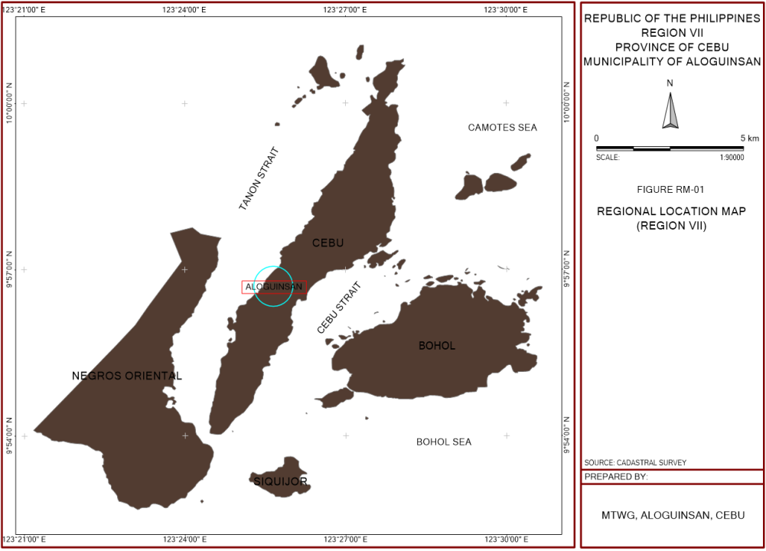Aloguinsan was formerly a barrio of Pinamungajan. It was created a town by virtue of the Royal Decree of the King of Spain in 1886. The first Capitan was Felomino Nengasca who became its first "Captain Municipal".

Bulwarte, a historic landmark, still stands as a mute testimony to the courage of the early inhabitants of Aloguinsan. Because of the frequent Moro attacks, the natives, under the supervision of the Spaniards, constructed a watchtower on top of a hill at the mouth of a river. From this vantage point, they could see incoming Moro vintas.

In the early days, a Spanish official met a native fisherman carrying the head of the fish called “kinsan” after its body was sold. The Spaniards asked, “commo se llama este lugar?”, which means what is the name of this place. The fishermen did not understand, but thinking that the Spaniards was asking him what he was carrying, answered, “Ah! Olo kinsan”. Since then, the place was called Olokinsan and later on change to Aloguinsan.

Aloguinsan is 1.23% of the total Cebu provincial area and classified as village (Tertiary Urban center) of the Province of Cebu. Its role is more on providing rural services and its other function is more on primary health care. Other criteria include urban population with more than 2,500. Economically, Aloguinsan contributes principally to the food requirements of the of the province particularly corn, coconut, rootcrops, vegetables and other staple crops. Coconut is still the major source of income in the municipality.

Aloguinsan is about 67 kilometers from Cebu City passing via Carcar City and about 72 kilometers via Toledo City. It is bounded on the North by the Municipality of Pinamungajan, on the east by Carcar City and Municipality of San Fernando, on the West by Tañnon Strait and on the south by the Municipality of Barili. It can be located in coordinates 10.19170 N, 123.56160 E.

The municipality of Aloguinsan comprises 15 barangays namely: Angilan, Bojo, Bonbon, Esperanza, Kandingan, Kantabogon, Kawasan, Olango, Poblaicon, Punay, Rosario, Saksak, Tampaan, Toyokon, and Zaragosa.

The topography of Aloguinsan is generally moderate to high relief with 30% of the area severely eroded. The highest elevation reaches 277 meters above the mean sea level situated at Barangay Kantabogon. Areas underlay with Carcar Fm’s marl unit, at the southern part of the municipality exhibit subdued terrain usually undulating to rolling. Contrary to the former areas on the northern to eastern part underlain with limestone display rugged grounds and steep gradient, V-shaped valleys are deeply entrenched in the hinterlands. Peaks are from rounded to elongated. Generally, its topography around 349.17 hectares or 5.57 percent are flat lowlands, while the biggest portion of the total land area approximately 4,833.03 hectares or 77.15 percent is classified under 18-35 percent slope or in the mountain and hilly areas located in the northeastern portion barangays.

|  |  |  |
| --- | --- | --- |
| Geographic Location | - | 10.117°N, 123.5616° E |
| No. of Barangays | - | 15 (2 urban & 13 rural) |
| Total Land Area | - | 5,533.35 hectares |
| Total Water Area | - | 10,720.37 hectares |
| Total Land and Water Area | - | 16,253.72 hectares |
| Land Distribution | - | 622.25 hectares or 11.25% urban land and 4,911.10 hectares or 88.75% rural land |

**Population and Social Services**

As of 2020 Census of Population from the Philippine Statistics Authority, the total population in the Municipality of Aloguinsan reached 34,466. The table below shows the population of the Local Government Unit for each of the 15 barangays.

The Gross Population Density in the municipality of Aloguinsan is 6 persons per hectare. The urban density of the municipality of Aloguinsan is 18 persons per hectare compared to the rural density of 4 persons per hectare.

It is also worth mentioning the four (4) urbanizing barangays of the municipality, namely: Kandingan, Tampaan, Angilan, and Bojo with population density range from 5-7 persons per hectare.

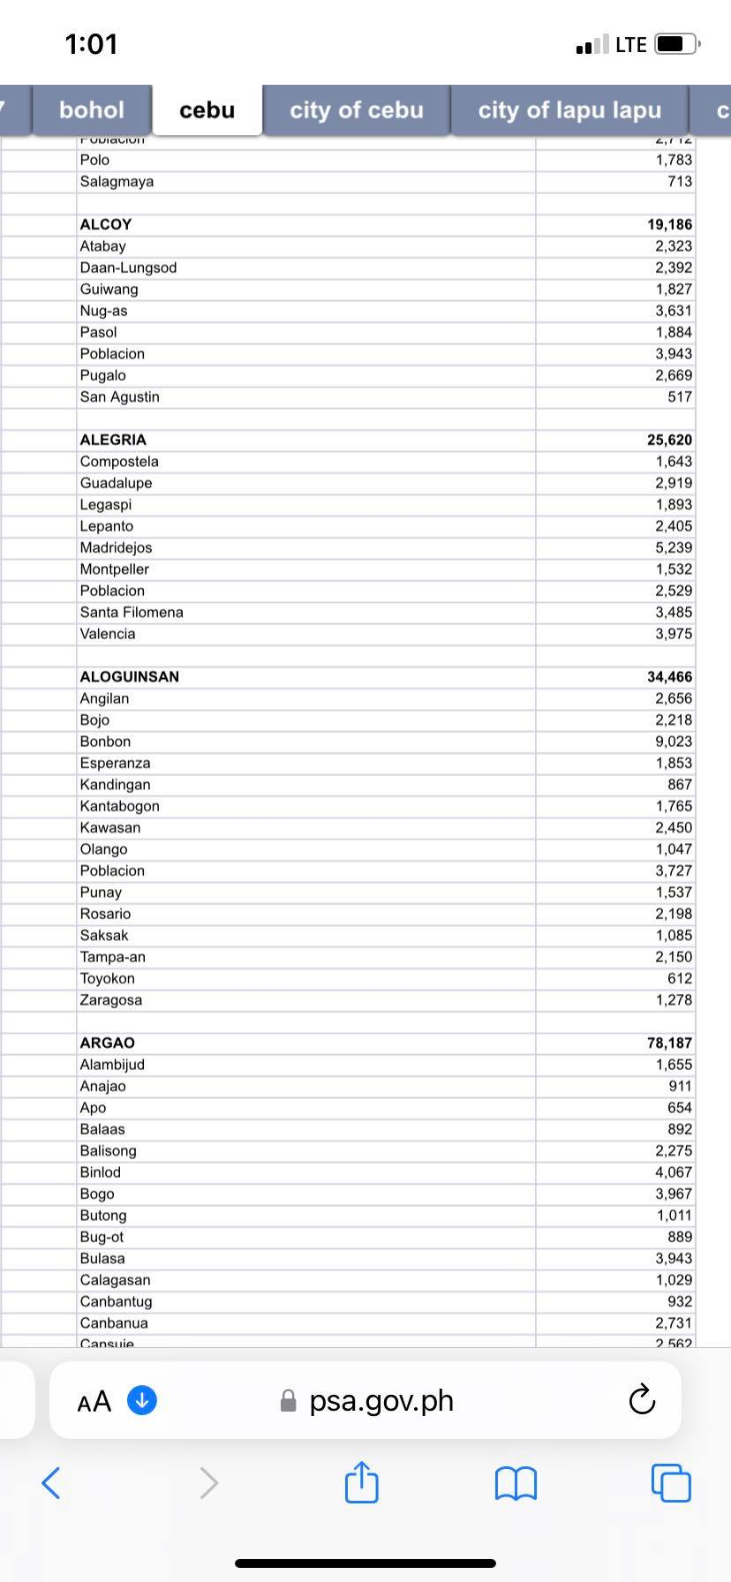

***Health***

Existing health facilities in Aloguinsan include one (1) Rural Health Unit (RHU) which serves as the main health center of the municipality, and one birthing center, both located in Barangay Poblacion. The municipality also has a total of four (4) Barangay Health Stations (BHS) located in the barangays of Bonbon, Olango, Rosario, and Zaragosa. For minor treatment and non-serious illnesses, patients are brought to the municipality’s main health center. The Rural Health Unit of Aloguinsan is a PHILHEALTH-accredited Out-Patient Konsulta Package Provider, offering free consultations, laboratory examinations, and medicines over the past year.

As of January 2025, these facilities have a collective health workforce composed of two (2) doctors, eight (8) nurses, one (1) sanitary inspector, nine (9) midwives, and one (1) medical technologist. The RHU is equipped with one (1) ambulance asset.

In the year 2024 the Municipality has a Crude Birth Rate (CBR) of 2.89%, Morbidity rate of 21.72%, Crude Death Rate of 3.56%, and the Infant Mortality Rate of 9.70%. There is no recorded Maternal Mortality in the past three (3) years.

**Ten Leading Causes of Morbidity for the Last Three Years**

**Municipality of Aloguinsan, Cebu**

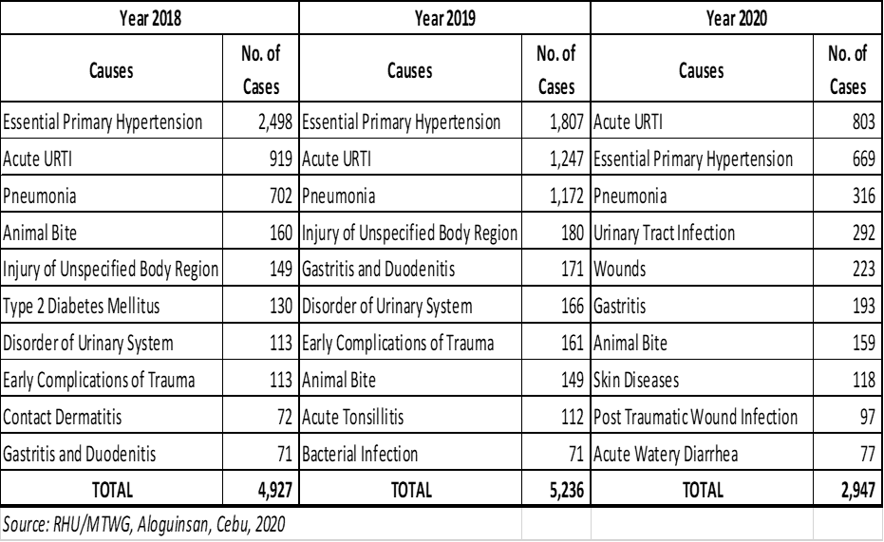

Ten (10) leading causes of mortality (all ages)

As to the mortality records, Chronic Ischemic Heart Disease tops the list in 3-year average (2018-2020). The incidence of disease has increased from 34 in the year 2018 to 70 in the year 2020 as shown in the Table.

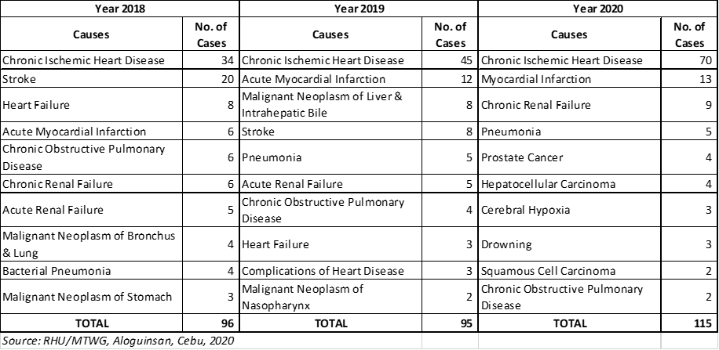

***Burial Grounds***

Currently, the municipality has two (2) burial grounds, both owned by public. These cemeteries occupy a total land area of approximately 1.58 hectares. Table SO-17 shows the inventory of burials grounds within the municipality.

***Social Welfare programs and services available***

Aloguinsan has a government agency-based social welfare institution operating in the municipality; it is the Municipal Social Welfare and Development Office (MSWDO). It is based at the ground floor of the municipal hall. As the welfare arm of the LGU, this office is manned by one (1) MSWD officer and three (3) personnel. Its clientele consists of disadvantaged families, women and children, PWDs, couples, solo parents, and the community especially in difficult circumstances. Multiple social services include pre-marriage orientation and counselling, distribution of family planning commodities, disaster response, AICS, PWD medical and educational assistance, issuance of indigent certificate, issuance of case summary, solo parent welfare program, aftercare and reintegration program.

The Office of Senior Citizens Affairs (OSCA) is also present in the municipality serving its members offering services such as honorarium for the OSCA head and officers, burial assistance, and senior citizen social pension.

***Education***

As Cebu Province got the 99% literacy rate in the year 2015, the municipality of Aloguinsan, also got the same with 99% literacy rate in the same period.

The municipality has a total of seventeen (17) elementary schools as of year 2020. All these facilities are being managed by the government. Most of these facilities are complete schools both equipped with primary and secondary education.

Public elementary schools of the municipality have total personnel of 203 teachers in 174 classrooms.

For school year 2020-2021, the total enrollment for elementary level is 5,260 handled by 203 teachers in 174 classrooms. The ratio of elementary teacher-student is 1:26 while the classroom-student ratio is 1:30.

The municipality has three (3) public secondary schools. These are the Aloguinsan National High School located in Barangay Poblacion with an approximate area of 7,000.00 square meters, Angilan National High School in Barangay Angilan with an area of 6,107.00 square meters, and the Rosario National High School in Barangay Rosario with an area of 1 hectare which has the largest area occupied among the secondary schools in the municipality.

***Housing***

The Municipality of Aloguinsan, Cebu has a total population of 32,100 based on 2015 Census of Population and Housing data. It has a total number of 6,901 households with an average of 4 to 5 persons per household.

As of the year 2015, the municipality of Aloguinsan has a total occupied housing unit numbering 6,886. The occupied housing units with a floor area of 5-9 sq. m (54-107 sq. ft) comprised of about 26 percent; housing units with this size of floor area have an average of 4.7 occupants per occupied housing unit.

Almost the same figure with floor area 10-19 sq. m (108-209 sq. ft) with the same average of 4.7 occupants per occupied housing unit. Housing units with floor area of 20-29 sq. m (210-317 sq. ft) consists of thirteen (13) percent with an average of 5.0 occupants per occupied housing unit.

***Recreation and Sports Facilities***

Major sport facility in Aloguinsan is the Alodome. It is located in Barangay Poblacion and has a floor area of approximately 1,700 square meters which can handle indoor and outdoor sports. It is one of the top-rated places listed as sports venue and stadium in the municipality.

Eight (8) out of fifteen (15) barangays of the municipality of Aloguinsan have its own sports and recreation facilities; most of which are multi-purpose covered courts which are generally used for outdoor sports activities such as basketball, volleyball, lawn tennis, and etc. Billiard halls also observed as indoor sport facilities in the municipality.

Majority of these sports’ facilities are in good conditions physically, but the availability of auxiliary facilities like toilets, benches, lightings and etc, are most likely inadequate/lacking if to include. Moreover, most of these are utilized as emergency action centers/evacuation centers during calamities and disaster thus sports and other socio-economic activities are being hampered.

Otherwise, seven (7) barangays have no existing sports facilities because of its location; in fact, some of them are utilizing the concrete roads for their sports activities.

***Protective Services***

In view of the delivery of protective services, the municipality of Aloguinsan has an existing police station located in Barangay Poblacion near the Alodome. It is a 2-storey building with an area of approximately 573.00 square meters. It is manned by twenty-seven (27) police personnel with 4 units of patrol car and 3 motorcycles to immediately responds to calls for police service.

According to NAPOLCOM, the standard police-population ratio is 1:1,000 which means that 1 policeman is required to watch over the safety of 1,000 residents. Currently, Aloguinsan has a total of 27 policemen serving the municipality. Based on the population of the municipality, the police-population ratio of the municipality was placed at 1:1,189 which is lower compared to the standard requirement.

On the other hand, the fire station of the municipality is located also in Barangay Poblacion. It has an area of 560.00 square meters and is manned by ten (10) fire personnel equipped with 2 units of fire truck and 1 motorcycle for emergency respond.

According to the Bureau of Fire Protection (BFP), the standard fireman-population ratio is 1:2,000 which means that 1 fireman is required to watch over the fire safety of 2,000 residents. Aloguinsan has only ten (10) firemen as of the year 2020. Based on the population, the fireman-population ratio of the municipality was placed at 1:3,210 which is much lower compared to the standard requirement.

***Crime Incidence***

For the last three (3) years 2018-2020, the crime collective volume for index crimes placed at 259 cases. The top recorded index crimes are traffic accidents, theft, and domestic violence with a total of 170 cases or 66% of the total index crimes in the municipality in the last 3 years.

For non-index crimes, the crime collective volume placed at 97 cases for the same period. The top recorded non-index crimes are anti-gambling law, illegal drugs, and the comprehensive firearm law with a total of 79 cases or 81% of the total non-index crimes in the municipality in the last 3 years.

***Fire Incidence***

Based on the data collected from Aloguinsan Fire Station, a total of thirty-two (32) fire incidents have been recorded for the last 5 years (2016-2020). Most of the incidents occurred in the residential areas.

**Local Economy**

***Agricultural Crops***

The Municipality of Aloguinsan, Cebu has a total land area of 5,533.35 hectares. About 5,114.32 hectares or 92% of the registered total land area is actively utilized to crop production, making agriculture as the major economic base of the municipality. Major crops raised include coconut, corn, tree crops, vegetables, root crops, banana, fruits, legumes. The combined production of food crops estimated at 4,765.51 MT annually. Crop production output were placed at 74% of the total agricultural output.

***Livestock and Poultry***

Based on the inventory conducted by the Municipal Agriculture Office, the municipality has a total livestock population of 11,651 heads with goats has the most number of heads with 5,359. For poultry products primarily chicken, both native and broiler has an estimated population of 101,049 heads. Livestock and poultry population are distributed to the 15 barangays in the municipality. The locations of livestock and poultry production has a vulnerability level to hazards from low to moderate.

Livestock and poultry subsector were placed at 20% of the total agricultural output.

***Fisheries***

Fishing is an important industry of the populace living along the four (4) coastal barangays of the municipality. Fishery production in the municipality is for self-sustenance. The majority of the fishermen in the locality are still considered marginal. The Tañon Strait is the venue of fishing activities. The fishery production estimated at 380.24 metric tons from the municipal fishing area. It has low rating to hazard vulnerabilities.

Fishery production placed at 6% of the total agricultural output of the municipality.

***Food Self-Sufficiency Assessment***

In Aloguinsan, domestic production is unable to keep up with household requirements. Several studies demonstrate that increasing agricultural productivity helps boosts rural incomes and increase food availability. However, the productivity levels of many cultivations and food staples produced in Aloguinsan are below national averages. This is due to a lack of knowledge of up to date technologies and practices, low use of improved and hybrid seeds or planting materials as well as inadequate irrigation facilities.

***Agricultural Support Facilities***

The Municipality of Aloguinsan has existing strengths to bolster agricultural productivity such as the presence of the Municipal Agriculture Office (MAO) that provides agricultural trainings extension works and a lot more that if properly tapped can enhance agricultural productivity.

The presence of Rural Based Organizations in both the farmers and fisherfolks can facilitate ease of delivery of crops, livestock and fishery related services throughout the municipality as well as the existence of micro credit facilities considered as an added factor.

Agriculture, forestry and fishing generates gainful employment in the province with 20.62% lower than the municipality with 33.5%.

***Manufacturing***

In terms of gainful employment, the manufacturing sector based on census data generates about 5.58% lower than the province with 13.75%.

***Construction***

Construction in the province of Cebu generates about 10.79% of gainful employment lower than the municipality of Aloguinsan with 21.41%.

***Mining and Quarrying***

Mining and quarrying generate employment of .40% lower than the province with .50%.

***Electricity, Gas and Water***

Electricity and gas generate gainful employment of .30% higher than the LGU Aloguinsan with only .28%.

In terms of economic structure, the municipality of Aloguinsan is an agriculture-based economy with the following ranking:

* Agriculture, forestry and fishery 1
* Industry 2
* Services 3

**Infrastructure and Physical Base**

***Inventory of Roads by Classification (barangay, city, municipal, provincial and national, length and type of pavement (concrete, asphalt, gravel and earth)***

The existing road network having a total length of 94.15 km. According to the Executive Order No. 180 series of 1948 “Establishing the Classification of Roads”, the Road Right of Way (RROW) for the national road, provincial road, municipal road, and barangay road are 20 meters, 15 meters, 10 meters, and 5 meters, respectively.

The municipality is being connected to the Municipality of Pinamungajan through the national road, which traverses the southeastern portion of the municipality thru Santander – Barili – Toledo Road. Provincial, municipal, and barangay roads of the municipality are connected to this national road.

Approximately 21.72 km or 23% of the total road network classified as national road, 12.68 km or 13% classified as provincial road, 1.32 km or 1% classified as municipal road, and 58.43 km or 62% classified as barangay road.

***Inventory of Bridges by classification (Barangay, city, Municipal, provincial, and national) length, type of construction (RCPC, steel truss, timber, others) and condition (passable)***

There are only few bridges in Aloguinsan that are sturdy, reliable, durable and sustainable even in the next ten (10) years for as long as:

* The width of the bridges should be widened, especially the old concrete bridges. They may become bottlenecks especially for big tucks; and
* The bottom of the creek, one kilometer upstream and one kilometer downstream should be maintained always and let free of obstructions

Some need to be maintained and rehabilitated in order to restore their functions and ensure the safety and efficiency of these bridges.

***Domestic Water Supply***

There are three (3) levels of water supply which serve the Municipality of Aloguinsan, the Level I, II, and III. According to the Municipal Engineer, there are only ten (10) barangays being served by the existing Level III water system.

There are shallow wells, dug wells, spring, and peddlers which can be found in different barangays in Aloguinsan. No record, however, can be made a reference source as to the condition of each well. There is strong indication, though, that some of these wells are already not functional.

Although almost all barangays have access to potable water, only those households in areas close to the barangay proper have level III water connections.

***Current Water Demand***

Out of 6,901 households in the municipality based on the 2015 PSA Survey, there are only 2,050 households being served by the Level III water system. Unserved households are currently obtaining the Level I and II water system.

This further shows the necessity for the local government to provide adequate and potable water supply. It Is really of at most importance for the local government to ensure that this need to be looked into and acted upon.

Important factors in analyzing and projecting the water demand per category are income level, standard of living, population characteristics towards water usage, topography, development and land use potentials of the service area.

Domestic Water Demand is the water demand by residential connections. A per capita domestic consumption of 110 liters per capita per day is used for the population served by residential connections.

***Other Water Sources***

Rainwater, rivers, lakes, streams, ponds and springs are natural sources of water. Dams, wells, tube wells, hand-pumps, canals, etc, are man-made sources of water.

Lead Water Agency/Local Water District/NWRB must regulate the drawing of underground water through the issuance of permit to draw.

There are other potential water sources in the Municipality of Aloguinsan that need to be fully developed and tapped. So far, there are no reported ground water contamination /pollution reported in the municipality for there are no major plantations in the upland barangays that use chemicals in their plantations. The presence of undeveloped wells and springs need development in order to supply water especially to the unserved households in the municipality.

The existence of these water sources will be of great value for few that will provide additional water supply if properly developed and conserved.

***Electric Power Supply***

The household connection level in the municipality as of April 2021 have reached to 87.97% of the total number of households based on 2021 projected number of households. This means that 7,281 households out of the projected 8,277 have electricity connections. However, 1,402 households or 12.03% remains unserved.

Electricity is provided by a local power cooperative – CEBECO III. However, the extent of its reach is only up to the areas close to the national highway and the major roads of the municipality. The remaining areas with no electricity are the far-flung sitios in the mountain barangay but plans are underway for the electrification of the said areas.

***Missionary Areas***

Portions of the remaining unenergized sitios and puroks are mostly remote and with dispersed households that are difficult to energize, requiring extensive resources, time and effort.

***Transport Facilities***

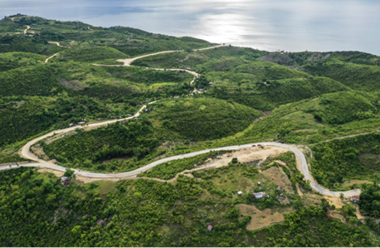The municipality is being connected to the Municipality of Pinamungajan through the national road, which traverses the southeastern portion of the municipality thru Santander – Barili – Toledo Road. Provincial, municipal, and barangay roads of the municipality are connected to this national road.

Approximately 21.72 km or 23% of the total road network classified as national road, 12.68 km or 13% classified as provincial road, 1.32 km or 1% classified as municipal road, and 58.43 km or 62% classified as barangay road.

Commuting to the municipality can be done by taking the bus or V-hire that route Aloguinsan destination. There are also bus that routes Awayan Carcar via Valencia or Toledo or Pinamungajan via Aloguinsan. It takes 2 hours to travel.

Inter-municipality public transportation includes tricycles and motorcycles-for-hire. The proliferation of unregulated motorcycle-for-hire in the barangays poses a threat to environmental sustainability and the rigid public as well.

The municipality has no existing terminal bus terminal. There are no designated bus stops and no proper parking facilities. On-street parking is a common practice.

There are no pedestrian crossings, overpasses, and underpasses in Aloguinsan as the flow of traffic is light, even in the main thoroughfares. The streets are well lighted and there are also available waiting sheds in selected locations for passengers waiting for rides.

Currently, the Municipality of Aloguinsan has a wharf facility in barangay Poblacion. It is a public facility which is being used as docking area local fishermen who buy or load ice before going to the deep sea for fishing. The facility is exposed to hazards like earthquake, typhoons, sea level rise, strong waves, and storm surge.

Based on standards of 2.4km/1000 population the municipality has sufficient roads. While the rural road based on standard of 1.5km/100 hectares arable land has an inadequacy of 18.29km.

***Communication Facilities***

The Municipality of Aloguinsan has its communication system through postal service, cellular mobile, and telephone landline.

There are five (5) cellular mobile providers covering the whole area of the Aloguinsan and other neighboring cities and municipalities. These providers are Smart Communications, Globe Telecom, and Sun Cellular for internet and cellular services.

There is also a telephone landline service in Aloguinsan through Smart and Globe Telecom.

***Waste Disposal System***

Only residual wastes and special wastes are collected to the five (5) barangays covered by the municipality’s garbage collection, namely: Bonbon, Poblacion, Bojo, Tampaan, and Angilan during Tuesdays, Wednesdays, and Fridays and this will be brought to a private engineered sanitary landfill in Barangay Tampaan named “San Rafael Engineered Sanitary Landfill”. Biodegradable wastes are only collected in town’s market and in proper Poblacion during Mondays and Thursdays and this will be brought to Central Compost Pit of the municipality. The remaining ten (10) barangays not covered by the garbage collection should build its Residual Containment Area (RCA) for the containment of their residual wastes and special waste and will be collected per cluster, one cluster per week and also brought to San Rafael Engineered Sanitary Landfill.

Some of the fifteen (15) barangays of the municipality have established their own individual Material Recovery Facility (MRF) and there are few barangays that their MRF are under construction or to be constructed because of budgetary reasons. The municipality also has a centralized MRF located in Barangay Tampaan.

A private engineered sanitary landfill in the municipality has allowed the local government of Aloguinsan to dump the collected wastes to their facility for free and signed a Memorandum of Agreement (MOA). The engineered sanitary landfill receives residual wastes only. The landfill will also follow the necessary guidelines mandated in the R.A. 9003 known as the Ecological Solid Waste Management Act.

One of the main problems in health and sanitation subsector is the number of households that has no sanitary toilets. Out of 6,901 households in the municipality, 5,359 households or about 78% have sanitary toilets while 1,542 households or 22% have unsanitary toilet facilities. The lack of toilets is attributed to the unavailability of water supply in the sitios and poverty.

***Port Facilities***

Currently, the Municipality of Aloguinsan has a wharf facility in barangay Poblacion. It is a public facility which is being used as docking area of local fishermen who buy or load ice before going to the deep sea for fishing. The facility is exposed to hazards like earthquake, typhoons, sea level ride, strong waves, and storm surge.

***Municipal Cemetery***

Currently, the municipality has two (2) burial grounds, both owned by public. These cemeteries occupy a total land area of approximately 1.58 hectares.

***Public Market***

Aloguinsan’s commerce and trade activities are concentrated in two (2) urban barangays namely Barangay Poblacion and Bonbon. The Central Business District is located in Barangay Poblacion and where the Public Market can be located.

**Environmental Management and Natural Resources**

***Soil***

Aloguinsan’s soil is generally clayey type. It is consisting of four (4) types, namely: Bolinao Clay, Faraon Clay, Hydrosol, and Lugo Clay. Lugo Clay occupies the largest portion of the municipality's land area with 2,674.03 hectares or 48.33%.

***Land Resources***

Based on cadastral survey of the Department of Environment and Natural Resources (DENR) VII, the municipality of Aloguinsan has no identified forestland. Although mangrove areas are identified as forest but it is covered in the water areas of the municipality.

The total land area of the municipality covering 5,533.35 hectares is considered as alienable and disposable (A & D) land and open for new developments.

The urban land use of Aloguinsan covering an aggregate area of 408.82 hectares or 7.39% of the total land area. This is comprised of residential, commercial, infrastructure and utilities, institutional, parks/playground and open spaces.

The agricultural area estimated at 5,114.32 hectares or 92.43% of the total municipal land area. An agro-industrial area 2.28 hectares, these are the locations of commercial poultry and livestock farms. Other land uses to include cemeteries, tourism and sanitary landfill with a combined total of 7.93 hectares or .14% of the total land area.

For water uses an aggregate area of 40.37 hectares or .38% of the total water area classified protection area while the 10,680 hectares or 99.62% classified as production area with a combined total of 10,720.37 hectares of municipal water. The combined land and water resources of the Aloguinsan placed at 16,253.72 hectares.

***Existing Land and Water Use***

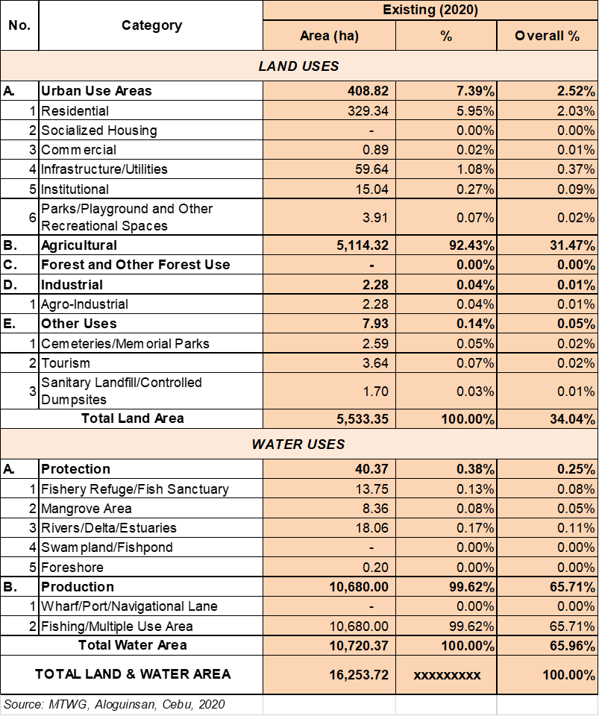

***Mineral Resources***

Mineral resources of Aloguinsan are mostly non-metallic deposits except for some minor metallic manganese nodule deposits. Evaluation of the area had identified potential prospects for cement raw materials, phosphates, guano deposits, stone craft materials, limestone, stone and rock aggregates. Prospects for manganese and silica sand were noted but were found to be of small quantity (Aleta & Lucero). In year 2006-2008, oil and gas exploration were conducted in Barangays Olango and Bonbon (offshore drilling).

***Coastal Resources***

Coral cover in the four coastal barangays was also assessed. The percent coral cover for live hard coral in Barangays Bojo and Bonbon.

In shallow area were both fair while deep area it was rated good. On the other hand, the two coastal barangays of Kantabogon and Poblacion, both got a rating of excellent in shallow area while in deep portion is good and fair respectively.

Substrate composition varies from site to site. Four (4) primary classifications are Hard coral (branching corals, foliose corals, encrusting corals, massive corals), Soft corals, Abiotic (dead corals, dead corals with algae, sand, silt, rubble rock) and others (seagrass, sponge, algae).

Of the three sites, Bonbon had a higher abiotic compositions (57.21%) compared to its hard coral cover (40.87%) at the surveyed portion of the reef. Anthropomorphic activities are evident in the area. High percentages of rubble and sand or silt (22.50% and 49.33% respectively) indicate gleaning activities which result in trampling the intertidal portion of the reef. The trauma of removing sessile benthic invertebrates such as Tridacna spp and other bivalves result in transforming hard corals such as fragile branching Acropora spp. To rubble. Run-off from rain and households also contribute to siltation and the smothering of corals contributing to dead corals (25.67%).

Poblacion- Bojo and Kantabogon had similar trends in terms of substrate composition. Both sites had high hard corals cover (61.38%) for Poblacion-Bojo and (77.88%) for Kantabogon. Evidence of some dead corals in Poblacion-Bojo and Kantabogon indicate the use of chemicals (cyanide, tubli) in fishing. The high algal cover of Poblacion-Bojo can be explained by the high productivity of the area due to its close proximity to a river system. Unexpectedly, siltation was not observed on the reef. Silt was visually observed to be confined at the edge of the river mouth and not on the reef flat itself.

***Seagrass Communities***

In Aloguinsan, only barangay Bonbon has the profound and wide seagrass areas, patches of seagrass beds can be observed at Bonbon, Poblacion, Bojo and Kantabogon due to their topography of abrupt steep slope of coral cover with minimal areas of gradual intertidal slopes.

***Mangrove Forests***

All mangroves found within the forestland were identified, counted and recorded. It has a total of 33.82 hectares of mangrove area, the only classified as forestland in the municipality.

A moderate mangrove growth for Barangay Bojo were located along the riverbank stretch starting up from the last boat docking area till near river outlet going to sea. The larger mangrove area at Bonbon is situated north of the barangay with Tutay River and the remaining areas are along coastal margin. Approximately 5 hectares along the Aloguinsan River were commonly shared by Barangays Bonbon and Poblacion where higher variety of mangrove species are found.

***Reef Fish Communities***

Fish population composition in a particular reef habitat is dependent on the physical (topography/substrate/temperature) chemical conditions (salinity) and the availability of food (productivity).

The sites surveyed in Aloguinsan shows three distinct types of habitats and as expected, provides habitat to different numbers of herbivores, piscivores, and invertebrate feeders.

Bonbon has a high omnivore count (76%) perhaps attributed to the vast sea grass beds providing a diverse selection of food sources: seagrass, algae, benthic and flanktonic invertebrates.

Poblacion-Bojo is similar to Kantabogon’s topography but quite sloping and is also located close to a river outlet, and as a consequence, is supplied with waters high in nutrients. A high number of flantivores (565), followed by omnivores (28%) and herbivores (14%) as well as having 10% algal cover indicates high productivity. Massive schools of sardines were spotted out of the transact areas can be associated with an abundance of phyto-and zooplankton; abundance of grazers such as Siganids is perhaps due to the high algal cover (10%).

Kantabogon has well pronounced steep drop-offs, reaching 45m. the unique topography has created an almost pelagic habitat and consequently, fish family composition also differs from the other sites, with only 20 families observed. Ten commercially important species were observed in this area namely sugeonfishes, triggerfishes, (Ballistiodes spp.) fusiliers, jacks, groupers, (juvenile), sweetlips, emperors, snapplers, parrotfishes and snappers but occurring only in few numbers and often in small sizes falling in the 11-20cm category. Fusiliers however were observed in medium to large groups ranging from 50-450 per school.

A similar trend was observed in all sites surveyed. All fishes sizes were <30cm, markedly dominated by the 1-10cm rank, followed by 11-20cm rank and 21-30cm size group with only a very few percentage of individuals. Bonbon had 92% (1-10cm), 7-8% 11-20cm), and ,2% 21-30cm). Poblacion-Bojo had 75% (1-10cm), 25% (11-20cm), and .01% (21-30cm). And Kantabogon had 96% (1-10cm), 3.8% (11-20cm), and .2% (21-30cm). Fishing activity in the area could account for the absence of large individuals in spite of the high level of coral cover.

***Fresh Water Resources***

Surface Run-Off

The surface drainage of the municipality is due to the existence of two (2) major rivers that traverse within the territorial jurisdiction of the municipality particularly the Aloguinsan River and the Bojo River.

Aloguinsan has about 6.2 kms. of shoreline from boundary of Pinamungahanto boundaryBarili. Directly to the west of the town is the Tanon Strait coastal waters characterized by shallow coral and rocky to sandy bottom. Remaining corals are however in poor to fair condition.

Upstream, two rivers and a creek are having their outlets at Aloguinsan. At the upper most is the Aloguinsan River and Bojo River in the lowland area.

Groundwater Resources

No official geo-resistivity study conducted to validate the groundwater resources. However, the existing 19 deep wells spread over the 15 barangays that are utilized for drinking water among residents indicates that a considerable supply of groundwater are available within the territorial jurisdiction of Aloguinsan.

**INSTITUTIONAL**

**The Local Disaster Risk Reduction and Management Council**

Sec. 11 of Republic Act 10121 provides for the organization of the local government level of the disaster Risk Reduction and Management Council and accordingly the existing Municipal Disaster Coordinating Council (MDCC) under PD 1566 shall henceforth be known as Municipal Disaster Risk Reduction and Management Council (MDRRMC).

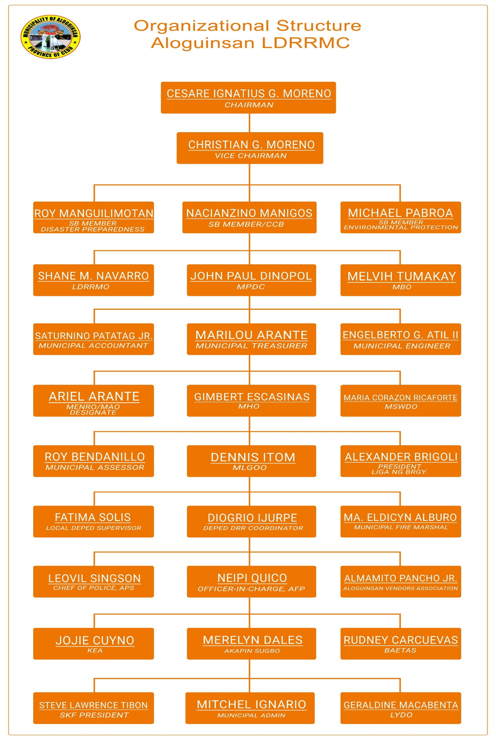

Functions – The MDRRMC shall have the following functions:

* Approve, monitor and evaluate the implementation of the LDRRMP and regularly review and test the plan consistent with other national and local planning programs;
* Ensure the integration of disaster risk reduction and climate change adaptation into local development plans, programs and budgets as a strategy in sustainable development and poverty reduction;
* Recommend the implementation of forced or preemptive evacuation of local residents, if necessary; and
* Convene the local council once every three months or as necessary

**The Local Disaster Risk Reduction and Management Office**

To assist the MDRRMC, there shall be a Municipal Disaster Risk Reduction and Management Office (MDRRMO) which shall be under the Office of the Mayor.

The LDRRM Office has permanent LDRRM Officer and three required staff assigned to Operations and Warning, Research and Planning, and Admin and Training. The emergency response team was also established under the LDRRM Office. There are a total of 15 personnel (both permanent and job order) assigned at the LDRRM Office.

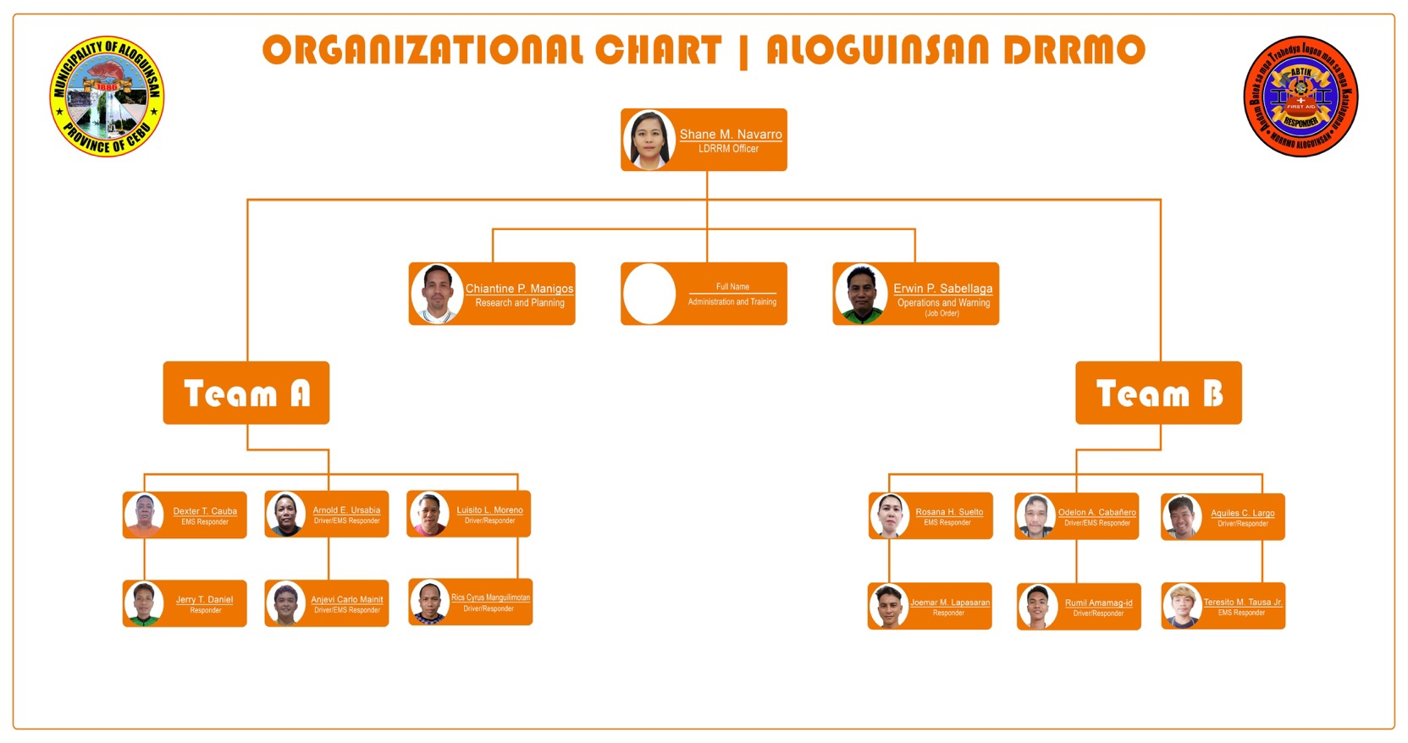

The LDRRMO shall have the following functions:

1. Design, program, and coordinate disaster risk reduction and management activities consistent with the National Council’s standards and guidelines;
2. Facilitate and support risk assessments and contingency planning activities at the local level;
3. Consolidate local disaster risk information which includes natural hazards, vulnerabilities, and climate change risks, and maintain a local risk map;
4. Organize and conduct training, orientation, and knowledge management activities on disaster risk reduction and management at the local level
5. Operate a multi-hazard early warning system, linked to disaster risk reduction to provide accurate and timely advice to national or local emergency response organizations and to the general public, through diverse mass media, particularly radio, landline communications, and technologies for communication within rural communities.
6. Formulate and implement a comprehensive and integrated LDRRMP in accordance with the national, regional and provincial framework, and policies on disaster risk reduction in close coordination with the local development councils (LDCs);
7. Prepare and submit to the local Sanggunian through the LDRRMC and the LDC the annual LDRRMO Plan and budget, the proposed programming of the LDRRMF, other dedicated disaster risk reduction and management resources, and other regular funding source/s and budgetary support of the LDRRMO / BDRRMC;
8. Conduct continuous disaster monitoring and mobilize instrumentalities and entities of the LGUs, CSOs, private groups and organized volunteers, to utilize their facilities and resources for the protection and preservation of life and properties during emergencies in accordance with existing policies and procedures;
9. Identify, assess and manage the hazards, vulnerabilities and risks that may occur in their locality;
10. Disseminate information and raise public awareness about those hazards, vulnerabilities and risks, their nature, effects, early warning signs and countermeasures;
11. Identify and implement cost-effective risk reduction measures/strategies;
12. Maintain a database of human resource, equipment, directories, and location of critical infrastructures and their capacities such as hospitals and evacuation centers;
13. Develop, strengthen and operationalize mechanisms for partnership or networking with private sector, CSOs, and volunteer groups;
14. Take all necessary steps on a continuing basis to maintain, provide, or arrange the provision of, or to otherwise make available, suitably-trained and competent personnel for effective civil defense and disaster risk reduction and management in its area;
15. Organize, train, equip and supervise the local emergency response teams and the ACDVs, ensuring that humanitarian aid workers are equipped with basic skills to assist mothers to breastfeed;
16. Respond to and manage the adverse effects of emergencies and carry out recovery activities in the affected area, ensuring that there is an efficient mechanism for immediate delivery of food, shelter and medical supplies for women and children, endeavor to create a special place where internally-displaced mothers can find help with breastfeeding, feed and care for their babies and give support to each other;
17. Within its area, promote and raise public awareness of and compliance with this Act and legislative provisions relevant to the purpose of this Act;
18. Serve as the secretariat and executive arm of the LDRRMC;
19. Coordinate other disaster risk reduction and management activities;
20. Establish linkage/network with other LGUs for disaster risk reduction and emergency response purposes;
21. Recommend through the LDRRMC the enactment of local ordinances consistent with the requirements of this Act
22. Implement policies, approved plans and programs of the LDRRMC consistent with the policies and guidelines laid down in this Act;
23. Establish a Provincial/ City/Municipal/Barangay Disaster Risk Reduction and Management Operations Center;
24. Prepare and submit, through the LDRRMC and the LDC, the report on the utilization of the LDRRMF and other dedicated disaster risk reduction and management resources to the local COA, copy furnished the regional director of the OCD and the Local Government Operations Officer of the DILG; and,
25. Act on other matters that may be authorized by the LDRRMC

**RISK PROFILE**

**All hazards**

The municipality of Aloguinsan is vulnerable to natural hazards mainly; Flood, Rain-Induced Landslide, Storm Surge and Liquefaction based from the result of the Climate and Disaster Risk Assessment. All 15 barangays are vulnerable to rain-induced landslide while only a few barangays are prone to flood, storm surge and liquefaction.

|  |  |  |  |  |  |
| --- | --- | --- | --- | --- | --- |
| MUNICIPALITY OF ALOGUINSAN | | | | | |
| **BARANGAY** | | **FLOOD** | **STORM SURGE** | **LIQUEFACTION** | **RAIN-INDUCED LANDSLIDE** |
| 1 | ANGILAN |  |  | ***√*** | ***√*** |
| 2 | BOJO | ***√*** |  |  | ***√*** |
| 3 | BONBON | ***√*** | ***√*** | ***√*** | ***√*** |
| 4 | ESPERANZA | ***√*** |  |  | ***√*** |
| 5 | KANDINGAN | ***√*** |  |  | ***√*** |
| 6 | KANTABOGON |  | ***√*** |  | ***√*** |
| 7 | KAWASAN | ***√*** |  |  | ***√*** |
| 8 | OLANGO |  |  |  | ***√*** |
| 9 | POBLACION | ***√*** | ***√*** | ***√*** | ***√*** |
| 10 | PUNAY |  |  |  | ***√*** |
| 11 | ROSARIO | ***√*** |  |  | ***√*** |
| 12 | SAKSAK | ***√*** |  |  | ***√*** |
| 13 | TAMPA-AN | ***√*** | ***√*** | ***√*** | ***√*** |
| 14 | TOYOKON |  |  |  | ***√*** |
| 15 | ZARAGOSA | ***√*** |  |  | ***√*** |
|  |  |  |  |  |  |

***Flooding***

The Philippines experiences about twenty (20) cyclones in a typical year, bringing heavy rainfall to the country. Heavy rainfall periodically inundates Aloguinsan extensively which can sauce damage to properties and impede daily activities of the residents.

The flood prone areas experienced different magnitudes of flooding throughout the past years. The reasons may be due to heavy rainfall, high tide, clogged up drainage system, illegal settlements, and poor urban planning which further aggravates the damage caused.

Based on the contributing factors such as affected population, properties and extent of flooding, Poblacion ranked number one as the top priority barangay with 1, 591 individuals affected. Bonbon followed suit with 828 individuals, next is Barangay Esperanza affecting 200, Bojo with 177, and top 5 is barangay Tampaan with 164 individuals. All the rest of the barangays have minimal impact for flooding.

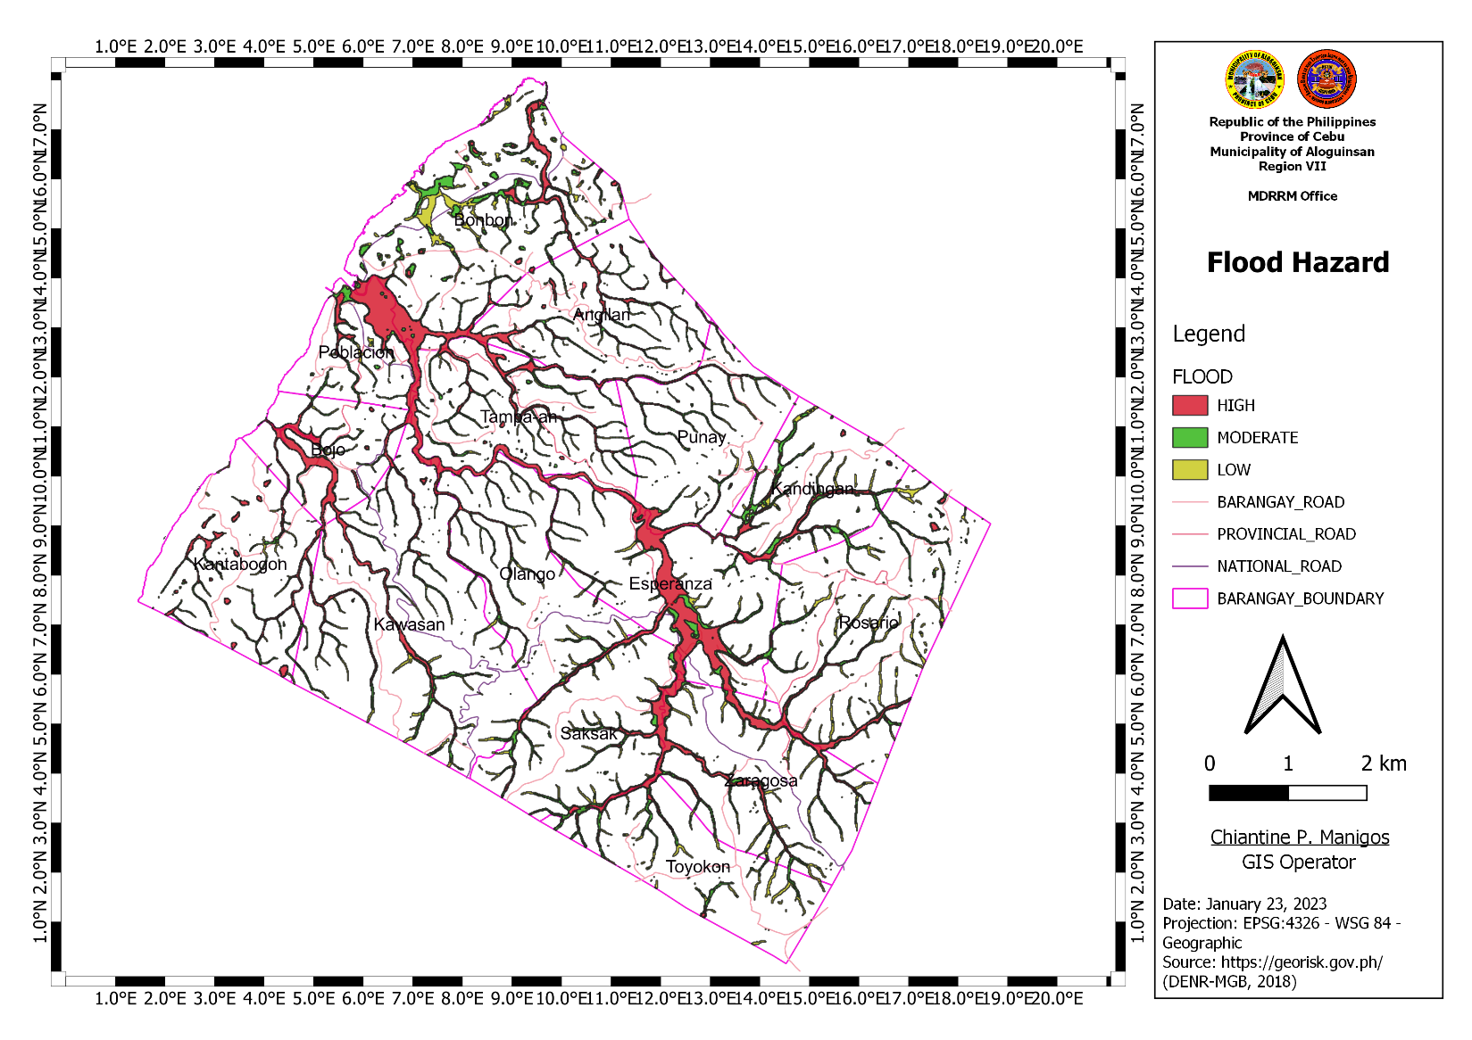

***Landslide***

Landslide in Aloguinsan is caused mainly by water, rain-induced. An estimated area of ____has. are prone to rain-induced landslide comprising all the 15 barangays with varying extent of effect. The summer monsoon brings heavy rains to most of the country from June to December.

Based on contributing factors such as affected population, properties and extent of landslide damage, Barangay Kawasan topped the list with 906 individuals affected, followed by Tampaan with 893, Punay with 753, Olango with 518, next is Kantabogon with 479 individuals.

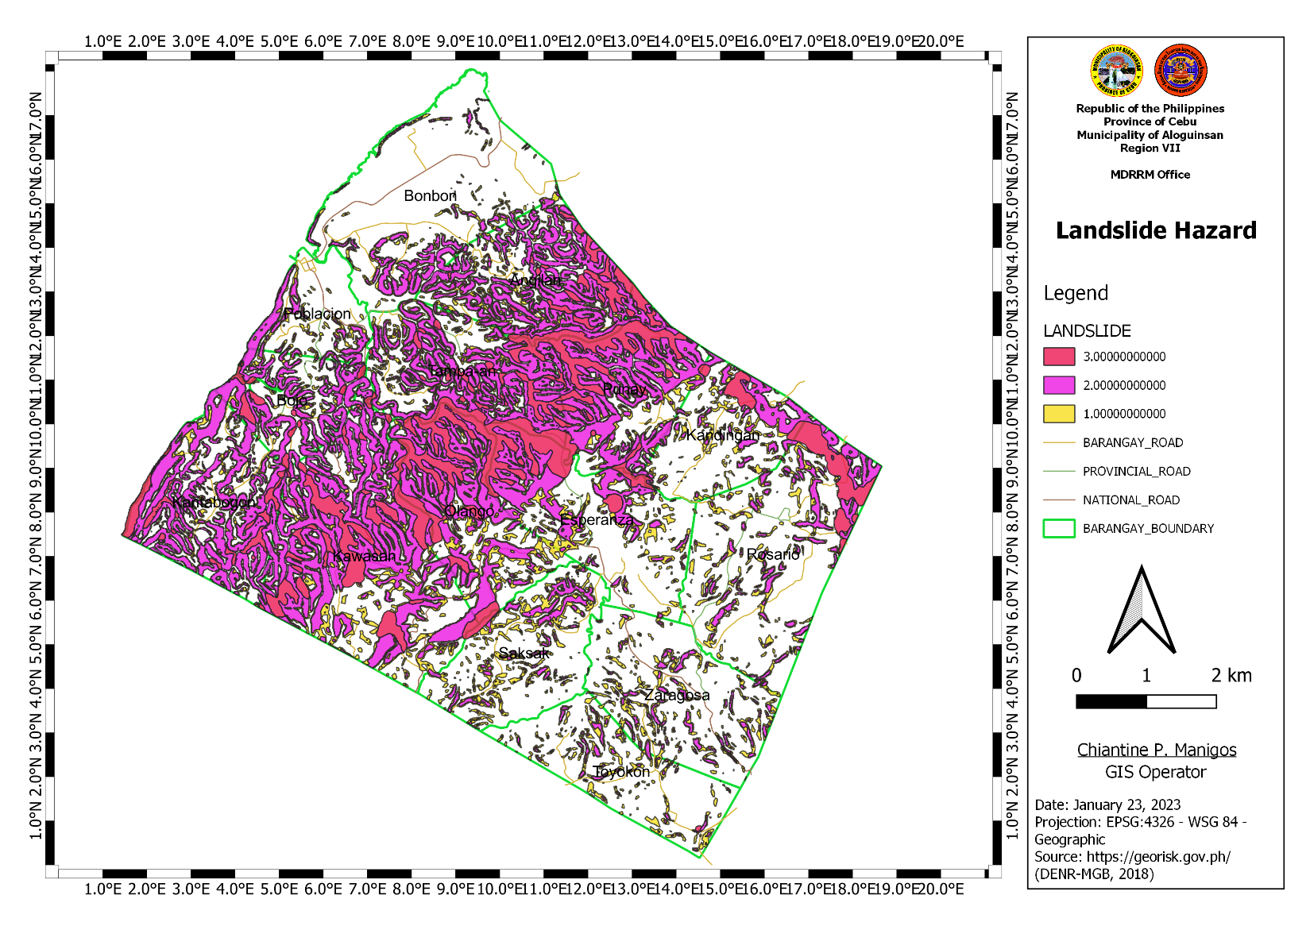

***Storm Surge***

A storm surge is a rise above the usual water level along the shore that is the result of strong onshore winds and/or reduced atmospheric pressure; the actual surge height is the difference of the observed water level  
minus the predicted tide.

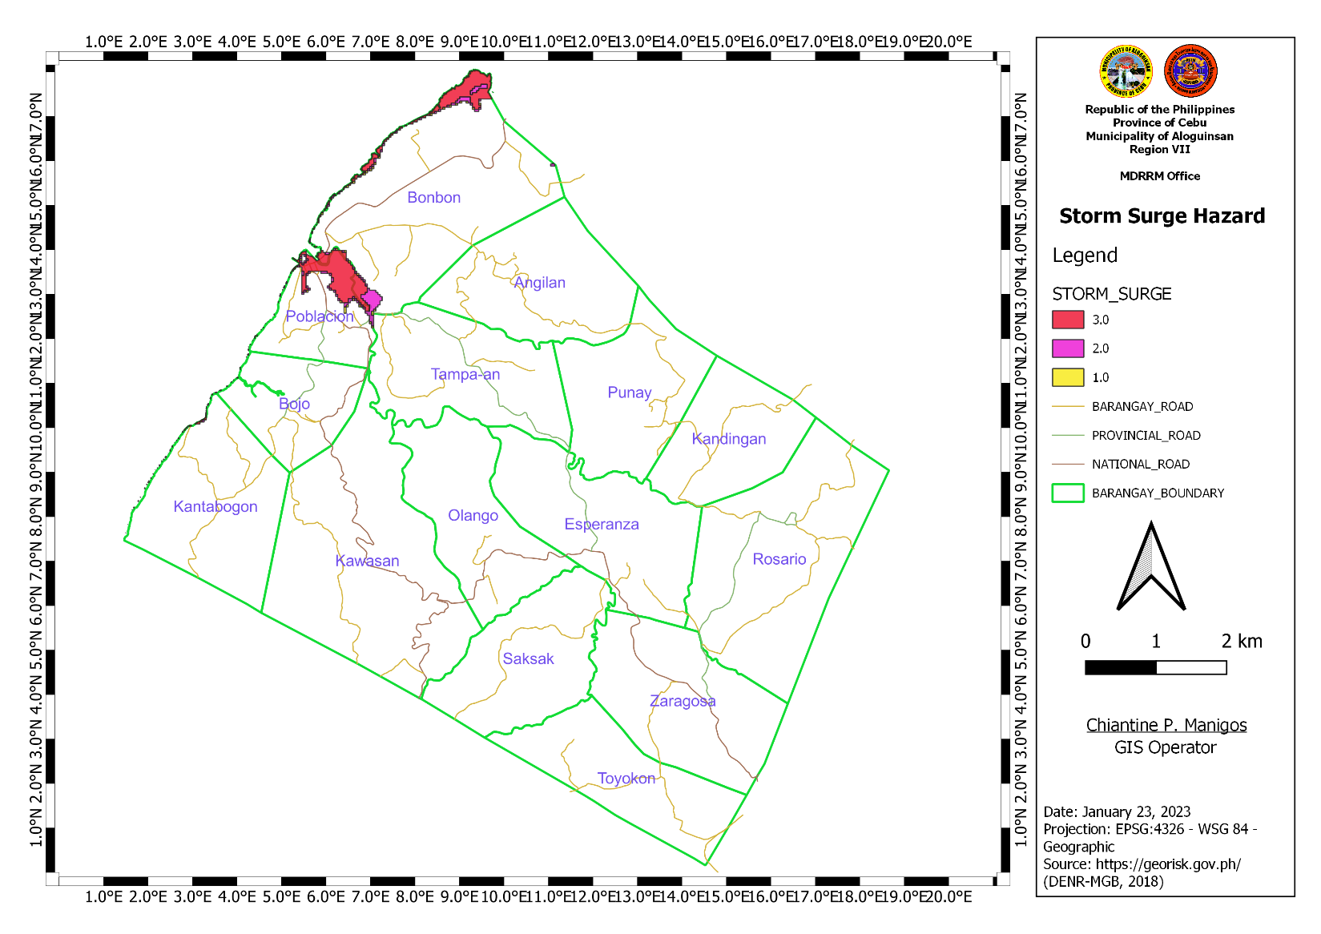

**Vulnerability, Capacity and Exposure**

Given that the LGU-Aloguinsan is prone to four hazards, CDRA results show the likelihood of occurrence, magnitude score as well as the vulnerable barangays, exposed population and capacities of those living in risk areas.

The tables below illustrate the vulnerability, exposure and capacity of the barangays per hazard.

**Landslide**

|  |  |  |  |  |  |  |  |  |  |
| --- | --- | --- | --- | --- | --- | --- | --- | --- | --- |
| **VULNERABLE**  **Barangay** | | **Land Use Category** | **HAZARD** | | | **EXPOSURE** | | **Risk  Category** | **CAPACITY** |
| **Landslide Susceptibility** | **Likelihood of Occurrence Score** | **Magnitude Score** | **Total Barangay Allocation in Hectares** | **Affected Area (Hectares) (GIS Derived)** |
|  |  | *Commercial, Residential, Industrial, Tourism, Open Space, Agri-industrial, etc.* | *Low, Moderate, High* | *Thru Anecdotal Account (Score range 1-6)* | *Magnitude scores are relative to the magnitude of the highest level of hazard category (see Scoring tab)* | *Total land area allocated per urban land use category (hectares)* | *Calculated land area exposed to hazard areas (hectares)* |  |  |
| 1 | Bonbon | Residential | Moderate | 4 | 0.66 | 73 | 16.5 | moderate | Available resources (manpower, extrication equipment, vehicles) |
| Parks & Recreation | Moderate | 4 | 0.66 | 0.4 | 0.16 | moderate |
| 2 | Poblacion | Residential | Low | 3 | 0.33 | 35.5 | 32.5 | low | Available resources (manpower, extrication equipment, vehicles) |
| Moderate | 4 | 0.66 | 35.5 | 2.78 | low |
| Commercial | Low | 3 | 0.33 | 0.7 | 0.7 | low |
| Parks & Recreation | Low | 3 | 0.33 | 1.5 | 1.5 | low |
| Cemeteries | Low | 3 | 0.33 | 0.8 | 0.8 | low |
| 3 | Angilan | Residential | Moderate | 4 | 0.66 | 23.4 | 21.95 | moderate | -Available resources (manpower, extrication equipment, vehicles) |
| Commercial | Moderate | 4 | 0.66 | 0.03 | 0.03 | moderate |
| Parks & Recreation | Moderate | 4 | 0.66 | 0.12 | 0.12 | moderate |
| 4 | Bojo | Residential | Low | 3 | 0.33 | 28.7 | 7.1 | low | -Available resources (manpower, extrication equipment, vehicles)  -Slope protection measure installed |
| Moderate | 4 | 0.66 | 28.7 | 19.8 | moderate |
| Parks & Recreation | Moderate | 4 | 0.66 | 0.07 | 0.07 | moderate |
| 5 | Esperanza | Residential | Low | 3 | 0.33 | 22.5 | 17.6 | low | -Available resources (manpower, extrication equipment, vehicles)  -slope protection measure installed |
| Moderate | 4 | 0.66 | 22.5 | 4.9 | moderate |
| Parks & Recreation | Low | 3 | 0.33 | 0.2 | 0.13 | low |
| Moderate | 4 | 0.66 | 0.2 | 0.07 | moderate |
| 6 | Kandingan | Residential | Moderate | 4 | 0.66 | 4.7 | 4.7 | moderate | -Available resources (manpower, extrication equipment, vehicles) |
| Parks & Recreation | Moderate | 4 | 0.66 | 0.08 | 0.08 | moderate |
| 7 | Kantabogon | Residential | Moderate | 4 | 0.66 | 18 | 18 | moderate | -Available resources (manpower, extrication equipment, vehicles) |
| Parks & Recreation | Moderate | 4 | 0.66 | 0.2 | 0.2 | moderate |
| Tourism | Moderate | 4 | 0.66 | 1 | 1 | Moderate |
| 8 | Kawasan | Residential | Low | 3 | 0.33 | 26 | 12.1 | low | -Available resources (manpower, extrication equipment, vehicles)  -slope protection installed |
| Moderate | 4 | 0.66 | 26 | 11 | moderate |
| High | 5 | 1 | 26 | 2.9 | moderate |
| Parks & Recreation | Moderate | 4 | 0.66 | 0.14 | 0.14 | moderate |
| Tourism | High | 5 | 1 | 0.7 | 0.7 | moderate |
| 9 | Olango | Residential | Low | 3 | 0.33 | 10.7 | 5.4 | low | -Available resources (manpower, extrication equipment, vehicles)  -slope protection installed |
| Moderate | 4 | 0.66 | 10.7 | 1.15 | Low |
| High | 5 | 1 | 10.7 | 4.1 | moderate |
| Parks & Recreation | Moderate | 4 | 0.66 | 0.05 | 0.05 | moderate |
| 10 | Punay | Residential | Moderate | 4 | 0.66 | 13.4 | 13.4 | moderate | -Available resources (manpower, extrication equipment, vehicles) |
| Parks & Recreation | Moderate | 4 | 0.66 | 0.1 | 0.1 | moderate |
| Dumpsite/Landfill | Moderate | 4 | 0.66 | 1.7 | 1.7 | moderate |
| 11 | Rosario | Residential | Moderate | 4 | 0.66 | 19.4 | 19.4 | moderate | -Available resources (manpower, extrication equipment, vehicles)  -slope protection measure installed |
| Commercial | Moderate | 4 | 0.66 | 0.13 | 0.13 | moderate |
| Parks & Recreation | Moderate | 4 | 0.66 | 0.7 | 0.7 | moderate |
| 12 | Saksak | Residential | Low | 3 | 0.33 | 10.8 | 10.8 | low | -Available resources (manpower, extrication equipment, vehicles) |
| Parks & Recreation | Low | 3 | 0.33 | 0.04 | 0.04 | low |
| 13 | Tampaan | Residential | Moderate | 4 | 0.66 | 21 | 18.5 | moderate | -Available resources (manpower, extrication equipment, vehicles) |
| Parks & Recreation | Moderate | 4 | 0.66 | 0.2 | 0.08 | moderate |
| Agri-industrial | Moderate | 4 | 0.66 | 2.3 | 2.3 | moderate |
| 14 | Toyokon | Residential | Low | 3 | 0.33 | 7.3 | 7.3 | low | -Available resources (manpower, extrication equipment, vehicles) |
| Parks & Recreation | Low | 3 | 0.33 | 0.04 | 0.04 | low |
| 15 | Zaragosa | Residential | Low | 3 | 0.33 | 15 | 7 | low | -Available resources (manpower, extrication equipment, vehicles)  -slope protection measure installed |
| Moderate | 4 | 0.66 | 15 | 8 | moderate |
| Parks & Recreation | Moderate | 4 | 0.66 | 0.2 | 0.2 | moderate |
| Cemeteries/ Memorial Parks | Low | 3 | 0.33 | 1 | 1 | low |
| *Source: MTWG, Aloguinsan, Cebu* | | |  |  |  |  |  |  |  |

**Flood**

|  |  |  |  |  |  |  |  |  |  |  |
| --- | --- | --- | --- | --- | --- | --- | --- | --- | --- | --- |
| **VULNERABLE**  **Barangay** | | **Land Use Category** | **HAZARD** | | | | **EXPOSURE** | | **Risk  Category** | **CAPACITY** |
| **Flood Susceptibility** | **Likelihood of Occurrence Score** | **Expected Flood Depth** | **Magnitude Score** | **Total Barangay Allocation in Hectares** | **Affected Area (Hectares) (GIS Derived)** |
|  |  | *Commercial, Residential, Industrial, Tourism, Open Space, Agri-industrial, etc.* | *Low, Moderate, High* | *Thru Anecdotal Account (Score range 1-6)* | *≤1m for moderate and Low ≤1m for high* | *Magnitude scores are relative to the magnitude of the highest level of hazard category (see Scoring tab)* | *Total land area allocated per urban land use category (hectares)* | *Calculated land area exposed to hazard areas (hectares)* |  |  |
| 1 | Bonbon | Residential | High | 5 | >1m | 1 | 73 | 34 | moderate | -Available resources (manpower, water rescue equipment, vehicles) |
| Parks & Recreation | High | 5 | >1m | 1 | 0.4 | 0.2 | moderate |
| Cemeteries | High | 5 | >1m | 1 | 0.8 | 0.8 | moderate |
| Tourism | High | 5 | >1m | 1 | 0.5 | 0.5 | moderate |
| 2 | Poblacion | Residential | High | 5 | >1m | 1 | 35.5 | 1.33 | moderate | -Available resources (manpower, water rescue equipment, vehicles) |
| 3 | Tampaan | Residential | High | 5 | >1m | 1 | 21 | 0.6 | moderate | -Available resources (manpower, water rescue equipment, vehicles) |
| *Source: MTWG, Aloguinsan, Cebu* | | |  |  |  |  |  |  |  |  |

**Storm Surge**

|  |  |  |  |  |  |  |  |  |  |  |
| --- | --- | --- | --- | --- | --- | --- | --- | --- | --- | --- |
| **VULNERABLE**  **Barangay** | | **Land Use Category** | **HAZARD** | | | | **EXPOSURE** | | **Risk  Category** | **CAPACITY** |
| **Hazard Susceptibility/ Intensity** | **Likelihood of Occurrence Score** | **Expected Inundation Depth** | **Magnitude Score** | **Total Barangay Allocation in Hectares** | **Affected Area (Hectares) (GIS Derived)** |
|  |  | *Commercial, Residential, Industrial, Tourism, Open Space, Agri-industrial, etc.* | *Low, Moderate, High/ Inundation Depth* | *Thru Anecdotal Account (Score range 1-6)* | *Depth according to hazard map* | *Magnitude scores are relative to the magnitude of the highest level of hazard category (see Scoring tab)* | *Total land area allocated per urban land use category (hectares)* | *Calculated land area exposed to hazard areas (hectares)* |  |  |
| 1 | Bonbon | Residential | Low | 3 | <0.5m | 0.33 | 73 | 0.64 | low | Available resources (manpower, water rescue equipment, vehicles)  -EO on Pre-emptive evacuation |
| Moderate | 4 | 0.5-1.5m | 0.66 | 73 | 0.35 | low |
| High | 5 | >1.5m | 1 | 73 | 0.12 | moderate |
| Tourism | High | 5 | >1.5m | 1 | 0.5 | 0.5 | moderate |
| 2 | Poblacion | Residential | Low | 3 | <0.5m | 0.33 | 35.5 | 0.7 | low | -Available resources (manpower, water rescue equipment, vehicles)  -EO on Pre-emptive evacuation |
| Moderate | 4 | 0.5-1.5m | 0.66 | 35.5 | 3.15 | low |
| High | 5 | >1.5m | 1 | 35.5 | 0.3 | moderate |
| Commercial | Moderate | 4 | 0.5-1.5m | 0.66 | 0.7 | 0.7 | moderate |
| Parks & Recreation | Moderate | 4 | 0.5-1.5m | 0.66 | 1.5 | 0.84 | moderate |
| High | 5 | >1.5m | 1 | 1.5 | 0.51 | moderate |
| 3 | Kantabogon | Residential | Low | 3 | <0.5m | 0.33 | 18 | 0.15 | low | Available resources (manpower, water rescue equipment, vehicles)  -EO on Pre-emptive evacuation |
| Tourism | Low | 3 | <0.5m | 0.33 | 1 | 0.3 | Low |
| High | 5 | >1.5m | 1 | 1 | 0.6 | Moderate |

**SITUATION ANALYSIS (Strengths, Weaknesses, Opportunities, Challenges)**

SWOC (strengths, weaknesses, opportunities, and challenges) analysis is a framework used to evaluate an organization’s competitive position and to develop strategic planning. SWOC analysis assesses internal and external factors, as well as current and future potential.

A SWOC analysis is designed to facilitate a realistic, fact-based, data-driven look at the strengths and weaknesses of an organization. The organization needs to keep the analysis accurate by avoiding pre-conceived beliefs or gray areas and instead focusing on real-life contexts.

The output of the SWOC analysis for the Municipality of Aloguinsan is based from the workshop conducted which was attended by the Local Disaster Risk Reduction and Management Council.

The SWOC analysis is done per DRRM thematic area.

**Disaster Prevention and Mitigation**

|  |  |  |  |
| --- | --- | --- | --- |
| **Strengths** | **Weaknesses** | **Opportunities** | **Challenges** |
| * Presence of risk maps * Presence of installed early warning signages * Presence of early warning devices * Franchising of PUVs is already under the LGU * Availability of evacuation center * Issuance of DRRM related policies (ordinance, EOs) * Forged MOA with private sector for the use of sanitary landfill * Presence of approved solid waste management plan * Regular collection of waste * Availability of CDRA result * Availability of funds for insurance coverage * Presence of insurance coverage for DRRM personnel including job orders and contract of service * 90% of farmers and fisher folks are registered in a LGU recognized organization | * Outdated CBMS data * Ease of implementation of “No Build Zone” * No available lot for relocation from the Municipality * No established policy requiring essential business establishment for the installation of back-up power * Absence of laboratory for water testing * No established early warning system * Limited evacuation center capacity * Presence of unmanaged, undeveloped, and privately owned destination sites which is hazardous to individuals visiting the site | * Availability of funding for relocation from NGAs * Implementation of transportation modernization program at the national level * Availability of technical assistance from warning agencies * Availability of advisories from warning agencies * Advancement of technology * Provision of building as evacuation center from PAGCOR * Availability of NDRRM Fund for the construction of evacuation center * With available risk assessment tool from the national | * Refusal of COVID-19 vaccination of senior citizens * No early warning system at the barangay level * Reluctance to registration of some farmers and fisher folks * Climate change * Poor maintenance of irrigation system * Different warning protocols and alert systems at the national level, creating confusion to LGUs |

**Disaster Preparedness**

|  |  |  |  |
| --- | --- | --- | --- |
| **Strengths** | **Weaknesses** | **Opportunities** | **Challenges** |
| * Established LDRRMC Council through E.O. * Regular conduct of council meetings * Established 24/7 Operations Center * Availability of local DRRM fund * Established LDRRM Office through E.O. * Filled-up plantilla positions for the LDRRMO including mandatory staffs * Availability of trained responders/   personnel   * Regular conduct of fire and earthquake drills * Presence of capable responders ANDAM BATOK SA TRAHEDYA INGON MAN SA KATALAGMAN (ABTIK) * Availability of equipment for disaster response * Presence of DRRM-H plan * Regular conduct of COVID-19 vaccination * Presence of school DRRM focal * Strong coordination among DRRMC members * Regular conduct of IEC activities * Availability of back-up power for critical establishments * Presence of renewable solar powered street lamps * Availability of water supply (springs, etc.) * Presence of water tanker for household use * Presence of water tanker * Allocated budget for the improvement of water systems * Presence of design software for water systems * Availability of handheld radios * Presence of NTC licensed radios and radio operators * Accessible municipal and barangay road networking * Availability of LGU vehicles * Presence of Barangay Animal Health Aide (BAHA) * Conduct of regular meeting of organized farmer association * Availability of surveillance drone for agricultural assessment * Presence of tourist destination * Availability of municipal market * LGU is open for investors * Full support from LCE and LGU officials * Presence of approved CDP * Presence of LPDRP * Presence IEC materials (pamphlets, leaflets, brochures) * Availability of localized IEC materials * Continuous conduct of information drive * Presence of GAD plan, budget with focal person * Presence of inventory of resources | * LDRRMC composition is incomplete based on RA 10121 * CDP and CLUP for updating * Lack of manpower in the LDRRM office * No separate facility for the operations center * Lack of DRRM related trainings (RDANA, PDNA, CP, ICS, PSCP) * Lack of responders/manpower * Lack of ambulance * Lack of health personnel * Lack of DRRM-related training for Teachers * Power supply is CEBECO-dependent * Some areas do not have access to water source * Lack of water supply for the irrigation system * No approved DRRM-related plans (CP, PSCP, SOP, RRP, RisCom Plan, etc.) * No separate office for GAD * Not yet trained in Gender Sensitivity training * No monitoring and evaluation scheme for DRRM PPAs implementation * Lack of training in search and rescue | * Presence of support from the higher DRRMCs * Established Barangay Development Councils through E.O. * Presence of support from OCD regional office * Availability of DRRM-related trainings from NGAs * Availability of DRRM-related policies as bases and guide in LDRRMF utilization * Presence of community fire auxiliary group (CFAG) * Presence of ACDV guidelines from the NDRRMC * Availability of heavy equipment on loan basis * Presence of augmentation support from neighboring LGUs * Availability of solar lamps from the NGAs * Availability of water tanker from private organizations * Availability of technical and financial assistance at the provincial level related to supply of water systems * Partnership with civic organizations and NGAs related to water systems * Availability of satellite phone at the provincial level * Linkage to the provincial and national government * Availability of funds at the provincial and national level * Availability of DRR-related plans at the regional and national level * Availability of technical experts in the formulation of plans * Presence of IEC materials in the regional level * Availability of technical experts for GAD training | * Irregular fuel rate * No Barangay DRRM plans * Various plans required by concerned national government agencies * Bureaucracy at the national government * Different COA interpretation on some national policies * Limited awareness and preparedness activities at the community level |

**Disaster Response and Early Recovery**

|  |  |  |  |
| --- | --- | --- | --- |
| **Strengths** | **Weaknesses** | **Opportunities** | **Challenges** |
| * Availability of food assistance for fisher folks during bad weather * Established 24/7 Operations Center * With available communication, rescue, and transportation equipment for operations and response * Conduct of RECOREDA as preparedness action * Strong partnership with other offices in conducting response and relief operations * Availability of quick response fund for response intervention | * Lack of SRR-trained response personnel * Lack of response resources * No response plans at the LGU level * Lack of response protocols * Report generation | * Availability of responders from neighboring LGUs for augmentation * Availability of national issuances for the declaration of state of calamity, conduct of pre-disaster risk assessment, utilization of QRF and among others that will serve as bases for LGU in the implementation of activities * Availability of national government agencies to augment resources to LGU * Availability of National and Regional Disaster Response Plans and Contingency for various hazards | * No established standard protocol during disaster response with the neighboring LGUs and volunteers * No MOA established with neighboring LGUs in disaster response * Reluctance of some members of the community in the implementation of pre-emptive/force evacuation * National declaration of assistance but different in the stated policy or guidelines. * Different reporting templates forwarded to LGUs for compliance from concerned national government agencies |

**Disaster Rehabilitation and Recovery**

|  |  |  |  |
| --- | --- | --- | --- |
| **Strengths** | **Weaknesses** | **Opportunities** | **Challenges** |
| * Regular conduct of mental health and psychosocial support * Provision of livelihood program | * No Rehabilitation and Recovery Plan (RRP) * Lack of PDNA-trained personnel * Developed livelihood products such as “door mat” are not saleable in the market | * Availability of livelihood training from private and government organizations * Availability of livelihood opportunity from NGAs * Availability of PDNA teams from higher DRRMCs * Availability of fund at the national level for rehabilitation program | * Bureaucracy at the national level for the provision of rehabilitation assistance * Lack of fund at the barangay level for rehabilitation |

**THEMATIC AREA PLAN**

**The Four Thematic Areas**

As mentioned earlier, the Disaster Risk Reduction and Management has four distinct yet mutually reinforcing thematic areas which are interoperable, no clear starting nor ending points where overlaps are expected, centered on problem-needs and asset-strengths, and point to one direction which is to reduce people's vulnerabilities and to increase people's capacity to prepare and mitigate the impacts of disasters. All efforts under each thematic area, when combined with the other thematic areas, would lead to the realization and achievement of the country's goal of safer, adaptive, and more resilient Filipino communities. This will also lead to the realization of the region's DRRM vision as graphically shown below.

**Disaster Prevention and Mitigation**

Avoid hazards and mitigate their potential impacts by reducing vulnerabilities and exposure and enhancing capacities of communities

**Disaster Preparedness**

Establish and strengthen capacities of communities to anticipate, cope and recover from the negative impacts of emergency occurrences and disasters

**Disaster**

**Response and Early Recovery**

Provide life preservation and meet the basic subsistence needs of affected population based on acceptable standards during or immediately after a disaster

**Disaster Rehabilitation and Recovery**

Restore and improve facilities, livelihood and living conditions and organizational capacities of communities, and reduced disaster risks in accordance with the “building back better” principle

**The Updated National Disaster Risk Reduction and Management Framework**

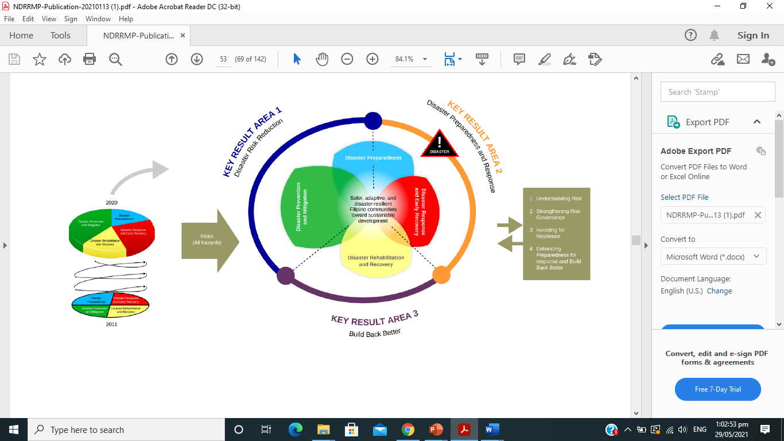

The updated framework has two primary features. The first feature shows the spiral transition, progress, and achievement toward realizing our resilience goal as depicted in the existing framework. The second feature depicts the transformation and recalibration of the framework that emphasizes a number of things:

***First***, the emphasis on the centrality of risk and focus on an all hazards approach. It recognizes that risks have a dynamic nature that changes over time with the interplay of people’s level of capacity and vulnerabilities amidst the changing climate, including extreme and slow onset events and manmade activities. It brings attention to the increasingly interconnected, cascading and complex nature of natural and human-induced hazards which links the discussion on DRRM, CCA and sustainable development (UNDRR and ISC, 2020).

***Second***, the inclusion of risk governance shows that institutional mechanisms and inclusive environments are enabling factors in empowering communities and giving them voices and spaces in decision making at different levels.

***Third***, by focusing on resilience strengthening, it underlies the importance of building adaptive, anticipatory, responsive, and transformative capacities of people and government. These four factors are important to be addressed in order to reduce existing risks and prevent new risks from developing.

***Fourth***, coherence and mutual reinforcement of strategies among actors and across thematic pillars is emphasized to improve the system and avoid working in silos. The framework recognizes the need to establish credible linkages to enhance coherence and harmonization across goals, systems, plans, and policies to avoid duplication, overlapping of efforts and wastage of resources. Thus, the thematic pillars and its corresponding Outcomes are organized and clustered into three (3) Key Result Areas (KRAs): KRA 1: Disaster Risk Reduction; KRA 2: Preparedness and Response; and, KRA 3: Build Back Better.

***Fifth***, the ***adoption of the four priorities for action of the SFDRR*** as strategies to achieve the overallgoal of disaster risk reduction and resilience. The framework unpacked the vision statementand highlighted the meaning of the different words. The following section qualitativelydescribes the country’s collective progress towards achieving the vision of resilience and willpresent the updated narratives to explain each component of the vision statement.

**DISASTER PREVENTION AND MITIGATION**

***Disaster Prevention*** – the outright avoidance of adverse impacts of hazards and related disasters. It expresses the concept and intention to completely avoid potential adverse impacts through action taken in advance such as construction of dams or embankments that eliminate flood risks, land-use regulations that do not permit any settlement in high-risk zones and seismic engineering designs that ensure the survival and function of a critical building in any likely earthquake.

***Disaster Mitigation*** – the lessening or limitation of the adverse impacts of hazards and related disasters. Mitigation measures encompass engineering techniques and hazard-resilient construction as well as improved environmental and public awareness.

**Objectives:**

* Implement risk-centered interventions
* Improve access, understanding, and use of updated risk information, DRR-related statistics, and research
* Institutionalize timely, responsive, context- and culture-specific early warning systems
* Improve and protect ecosystem integrity

**Outcomes:**

* Increased structural integrity of housing, building, and critical infrastructure
* Natural resources and ecosystem integrity are improved and sustained
* Improved access, understanding, and use of updated risk information, DRR-related statistics, and research
* Institutionalized timely, responsive, context- and culture-specific early warning systems

PREVENTION AND MITIGATION

**Goal: Address current and reduce future risk of communities and government through mainstreaming integrated risk management into science, policy and practice.**

|  |  |  |  |  |  |  |  |  |  |  |
| --- | --- | --- | --- | --- | --- | --- | --- | --- | --- | --- |
| **OBJECTIVES** | **OUTCOMES** | **OUTPUTS** | **PPAs** | **Target** | **Indicator** | **Timeframe** | | | **Source of Funds** | **Lead Office/ Department** |
| **2023** | **2024** | **2025** |
| Institutionalize timely, responsive, context- and culture-specific early warning systems | Institutionalized timely, responsive, context- and culture-specific early warning systems reaching the last mile | Operational end-to-end, and multi-hazard early warning | **Establishment of Early Warning System** | 6 EWS | No. of established EWS | 100K |  |  | LDRRMF | LDRRMO |
| Improve access, understanding, and use of updated risk information, DRR-related statistics, and research; | Improved access, understanding, and use of updated risk information, DRR-related statistics, and research | Information management and systems | **Conduct and establishment of information database - CBMS** | 1 database | No. of established database - CBMS | 250K |  |  | LDRRMF | LDRRMO |
| Implement risk-centered sectoral policies, plans and budgets | Implemented risk-centered national, sub-national, and sectoral policies, plans, and budgets | DRRM-CCA, and environmental policies, plans and budgets at all levels | **Creation and issuance of policy requiring business entities to plant trees prior to the renewal/granting of business permits** | 1 policy | No. of created and issued policies | 5K |  |  |  | LDRRMO |
| Implement risk-centered sectoral policies, plans and budgets | Implemented risk-centered national, sub-national, and sectoral policies, plans, and budgets | DRRM-CCA, and environmental policies, plans and budgets at all levels | **Creation and issuance of policy on illegal cutting of trees** | 1 policy | No. of created and issued policies | 5K |  |  |  | LDRRMO |
| Improve access, understanding, and use of updated risk information, DRR-related statistics, and research | Improved access, understanding, and use of updated risk information, DRR-related statistics, and research | Disaster and climate risk information | **Installation of Early Warning Signages** | 15 barangays | No. of barangays installed with signages | 15K | 15K |  | LDRRMF | LDRRMO |
| Implement risk-centered interventions | Improved access, understanding, and use of updated risk information, DRR-related statistics, and research | Resilient infrastructure system | **Construction of spillway** | 1 project | No. of projects constructed |  | 1M |  | Dev Fund  LDRRMF | MEO |
| Disaster-resilient human settlements | Disaster-resilient human settlements | Resilient communities | **Improvement of flood control system** | 1 flood control system | No. of flood control systems improved |  | 500K |  |  | MEO |
| Improve and protect ecosystem integrity | Natural resources and ecosystem integrity are improved and sustained | Nature-based solutions | **Conduct of river and coastal clean-up and tree planting** | 2 activities | No. of activities conducted | 50K |  |  | LDRRMF | LDRRMO |
| Access to effective, responsive and inclusive risk financing and insurance mechanisms. | Access to effective, responsive and inclusive social protection, risk financing and insurance mechanisms | Accessible disaster risk financing strategies | **Procurement of insurance premium of LGU owned buildings** | 1 procurement | No. of procurement undertaken | 200K |  |  | LDRRMF | LDRRMO |
| Access to effective, responsive and inclusive risk financing and insurance mechanisms. | Access to effective, responsive and inclusive social protection, risk financing and insurance mechanisms | Accessible disaster risk financing strategies | **Procurement of insurance premiums for volunteers/responders group insurance** | 1 procurement | No. of procurement undertaken | 50K |  |  | LDRRMF | LDRRMO |

**DISASTER PREPAREDNESS**

***Disaster Preparedness*** – the knowledge and capacities developed by governments, professional response and recovery organizations, communities and individuals to effectively anticipate, respond tom and recover from the impacts of likely, imminent or current hazard events or conditions. Preparedness action is carried out within the context of DRRM and aims to build the capacities needed to efficiently manage all types of emergencies and achieve orderly transitions from response to sustained recovery. Preparedness is based on a sound analysis of DRR and good linkages with early warning systems and includes such activities as contingency planning, stockpiling of equipment and supplies, the development of arrangements for coordination, evacuation and public information and associated training and field exercises. These must be supported by formal, institutional, legal and budgetary capacities.

**Objectives:**

* Develop and implement comprehensive and mutually-reinforcing national and local disaster preparedness and response plans and systems.
* Equip governments, institutions, communities, families, and individuals with the necessary skills to respond and cope with the adverse impacts of disasters
* Increase the level of awareness and understanding of governments and communities of hazards, exposure, and vulnerabilities

**Outcomes:**

* Implemented comprehensive and mutually-reinforcing national and local preparedness and response plans, policies, and system
* Enhanced risk awareness and risk-informed decisions and actions of governments and communities
* Equipped governments, institutions, communities, families, and individuals with the necessary skills and resources to respond and cope with the adverse impacts of disasters

**PREPAREDNESS**

**Goal: Establish and strengthen capacities of governments, communities, CSOs, and private sector to anticipate, cope, and recover from the adverse impacts of hazards and potential cascading disasters, and minimize losses and disruption of daily life.**

|  |  |  |  |  |  |  |  |  |  |  |
| --- | --- | --- | --- | --- | --- | --- | --- | --- | --- | --- |
| **OBJECTIVES** | **OUTCOMES** | **OUTPUTS** | **PPAs** | **Target** | **Indicator** | **Timeframe** | | | **Source of Funds** | **Lead Office/ Department** |
| **2023** | **2024** | **2025** |
| Develop and implement comprehensive and mutually-reinforcing national and local disaster preparedness and response plans and systems. | Implemented comprehensive and mutually-reinforcing national and local preparedness and response plans, policies, and system | Enhanced preparedness and response strategies, including coordination and budgeting mechanisms | **Conduct of LDRRMC full council meetings (Regular, Special, Emergency)** | 12 council meetings | No. of meeting conducted | 30K | 30K | 30K | LDRRMF | LDRRMO |
| Develop and implement comprehensive and mutually-reinforcing national and local disaster preparedness and response plans and systems. | Implemented comprehensive and mutually-reinforcing national and local preparedness and response plans, policies, and system | Increased coordination for disaster response | **Formulation of Standard Operating Procedures** | 3 SOPs | No. of SOPs formulated |  |  |  |  | LDRRMO |
| Equip governments, institutions, communities, families, and individuals with the necessary skills and resources to respond and cope with the adverse impacts of disasters | Equipped governments, institutions, communities, families, and individuals with the necessary skills and resources to respond and cope with the adverse impacts of disasters | Enhanced preparedness and response strategies, including coordination and budgeting mechanisms | **Procurement of rescue equipment** | 3 purchases | No. of purchases undertaken | 1M | 1M | 1M | LDRRMF | LDRRMO |
| Develop and implement comprehensive and mutually-reinforcing local disaster preparedness and response plans and systems. | Implemented comprehensive and mutually-reinforcing national and local preparedness and response plans, policies, and system | Enhanced preparedness and response strategies, including coordination and budgeting mechanisms | **Formulation of Barangay DRRM Plans** | 15 barangays | No. of Barangay DRRMPs formulated | 200K |  |  | LDRRMF  BDRRM Fund | LDRRMO |
| Increase the level of awareness and understanding of governments and communities of hazards, exposure, and vulnerabilities | Enhanced risk awareness and risk-informed decisions and actions of governments and communities | Inclusive and comprehensive national and local DRRM and CCA information, education, and communication (IEC) plans and programs | **Printing/production of IEC materials (flooding, landslide, storm surge, liquefaction)** | 4 Hazards | No. of hazards with IEC materials | 30K | 50K | 50K | LDRRMF | LDRRMO |
| Increase the level of awareness and understanding of governments and communities of hazards, exposure, and vulnerabilities | Enhanced risk awareness and risk-informed decisions and actions of governments and communities | Inclusive and comprehensive national and local DRRM and CCA information, education, and communication (IEC) plans and programs | **Conduct of IEC activities** | 3 activities | No. of activities conducted | 50K | 50K | 50K | LDRRMF | LDRRMO |
| Equip governments, institutions, communities, families, and individuals with the necessary skills to respond and cope with the adverse impacts of disasters | Increased institutional capacities of Local DRRM Councils and Offices | Self-reliant, fully-functioning, adequately-staffed, and financially-capable local DRRM council and office | **Conduct of DRRM related trainings (ICS, EMT, Rope Rescue, others)** | 5 tra**i**nings | No. of trainings conducted | 200K |  |  | LDRRMF | LDRRMO |
| Increase the level of awareness and understanding of governments and communities of hazards, exposure, and vulnerabilities | Enhanced risk awareness and risk-informed decisions and actions of governments and communities | Inclusive and comprehensive national and local DRRM and CCA information, education, and communication (IEC) plans and programs | **Formulation of LCCAP** | 1 LCCAP | No. of LCCAP formulated | 160K |  |  | LDRRMF | MLGOO |
| Develop and implement comprehensive and mutually-reinforcing national and local disaster preparedness and response plans and systems | Implemented comprehensive and mutually-reinforcing national and local preparedness and response plans, policies, and system | Continuity of essential services | **Formulation of Public Service Continuity Plan (PSCP)** | 1 PSCP | No. of PSCP formulated | 160K |  |  | LDRRMF | LDRRMO |
| Increase the level of awareness and understanding of governments and communities of hazards, exposure, and vulnerabilities | Enhanced risk awareness and risk-informed decisions and actions of governments and communities | Inclusive and comprehensive national and local DRRM and CCA information, education, and communication (IEC) plans and programs | **Conduct drills and exercises (NSED, Fire Drill, SIMEX)** | 12 activities | No. of activities conducted | 15K | 15K | 15K | LDRRMF | LDRRMO |
| Increase the level of awareness and understanding of governments and communities of hazards, exposure, and vulnerabilities | Enhanced risk awareness and risk-informed decisions and actions of governments and communities | Inclusive and comprehensive national and local DRRM and CCA information, education, and communication (IEC) plans and programs | **Observance of National Disaster Resilience Month** | 3 programs | No. of program conducted | 100K | 100K | 100K | LDRRMF | LDRRMO |
| Develop and implement comprehensive and mutually-reinforcing national and local disaster preparedness and response plans and systems. | Implemented comprehensive and mutually-reinforcing national and local preparedness and response plans, policies, and system | Enhanced preparedness and response strategies, including coordination and budgeting mechanisms | **Formulation of Strategic Risk Communication Plan** | 1 Risk Com plan | No. of risk com plan formulated |  | 200K |  | LDRRMF | LDRRMO |
| Equip governments, institutions, communities, families, and individuals with the necessary skills and resources to respond and cope with the adverse impacts of disasters | Equipped governments, institutions, communities, families, and individuals with the necessary skills and resources to respond and cope with the adverse impacts of disasters | Enhanced preparedness and response strategies, including coordination and budgeting mechanisms | **Renewal of handheld radio license** | 1 renewal | No. of renewal undertaken | 15K |  |  |  |  |

**DISASTER RESPONSE AND EARLY RECOVERY**

Disaster Response provides for key actions that give importance to activities during the actual disaster response operations such as needs assessment, search and rescue, relief operations, and early recovery activities. The activities identified below will be done either before the actual response operations or during the disaster event. For those activities that need to be completed prior to actual response operations, they will be linked to activities earlier identified in the preparedness aspect. However, to ensure that the proper response “lens” is issued in doing said activities, they have been included in this aspect. Overall, the success and realization of this priority area rely heavily on the completion of the activities under both the prevention and mitigation and preparedness aspects.

This aspect includes Early Recovery which shall officially commence provided that all the following conditions are met:

* The overall priority of emergency management has shifted from life-saving to life-sustaining;
* The emergency situation has been stabilized and operations in the affected areas are completely safe and permissible for the conduct of various forms of humanitarian assistance;
* Present number of displaced population has peaked and there is an observed and sustained downward trend and
* There is an established and uninterrupted disaster relief system to sustain the provision of emergency food and non-food items to affected families

**Objectives:**

* To ensure the timely, effective and well-coordinated response action
* To activate emergency operations center equipped with response workforce and volunteers
* To evacuate safely, preemptively and immediately, affected communities and ensure their safety
* To activate risk and forecast-based actions to forecasted affected communities
* To ensure adequate, prompt and well-coordinated assessment of needs and damages
* To ensure the timely, effective and well-coordinated response action and humanitarian logistics among cluster members and other actors

**Outcomes:**

* Affected communities are provided with gender-responsive, culture and conflict-sensitive basic necessities and services
* Well-establisheddisasterresponse operations withwell-equippedworkforceand volunteers
* Appropriate Early Actions are provided to communities
* Accurate reliable, and timely information management

**RESPONSE AND EARLY RECOVERY**

**Goal: Provide risk-based, timely and anticipatory response actions to address basic, life preservation and immediate needs of communities and government. Also, affected communities/ populations are able to continue life with dignity and prevent or minimize exacerbation of emergency situations.**

|  |  |  |  |  |  |  |  |  |  |  |
| --- | --- | --- | --- | --- | --- | --- | --- | --- | --- | --- |
| **OBJECTIVES** | **OUTCOMES** | **OUTPUTS** | **PPAs** | **Target** | **Indicator** | **Timeframe** | | | **Source of Funds** | **Lead Office/ Department** |
| **2023** | **2024** | **2025** |
| To ensure the timely, effective and well-coordinated response action | Affected communities are provided with gender-responsive, culture and conflict-sensitive basic necessities and services | Provided basic necessities and services to the affected population prioritizing the marginalized sector | **Conduct support to response operations** | 100% needed response operations conducted | Percentage of needed response operations conducted | 20K | 20K | 20K | LDRRMF | LDRRMO |
| To ensure the timely, effective and well-coordinated response action | Affected communities are provided with gender-responsive, culture and conflict-sensitive basic necessities and services | Provided basic necessities and services to the affected population prioritizing the marginalized sector | **Conduct of relief operations** | 100% needed relief operations conducted | Percentage of needed relief operations conducted | 20K | 20K | 20K | LDRRMF | MSWDO |
| To ensure the timely, effective and well-coordinated response action | Affected communities are provided with gender-responsive, culture and conflict-sensitive basic necessities and services | Activated 24/7 operations center | **Support to 24/7 LDRRM Operation Center (repair and maintenance of rescue vehicle, POL supplies, food supplies)** | 100% of needed support provided | Percentage of needed support provided | 20K | 20K | 20K | LDRRMF | LDRRMO |
| To activate emergency operations center equipped with response workforce and volunteers | Well-establisheddisasterresponse operations withwell-equippedworkforceand volunteers | Activated functional EOC | **Activation and support to EOC** | 1 EOC activated | No. of EOC activated | 20K | 20K | 20K | LDRRMF | LDRRMO |
| To evacuate safely, preemptively and immediately, affected communities and ensure their safety | Appropriate Early Actions are provided to communities | Activated forecast-based early actions | **Conduct pre-emptive/forced evacuation** | 100% needed evacuation conducted | Percentage of needed evacuation conducted | 10K | 10K | 10K | LDRRMF | LDRRMO |
| To ensure the timely, effective and well-coordinated response action | Well-establisheddisasterresponse operations withwell-equippedworkforceand volunteers | Activated response clusters | **Activate Response Clusters** | 100% needed response clusters activated | Percentage of needed response clusters activated | 10K | 10K | 10K | LDRRMF | LDRRMO |
| To ensure the timely, effective and well-coordinated response action | Affected communities are provided with gender-responsive, culture and conflict-sensitive basic necessities and services | Provided basic necessities and services to the affected population | **Support to emerging and re-emerging infectious diseases (EREID)** | 100% needed support provided | Percentage of needed support provided | 100K | 100K | 100K | RHU Budget | RHU |
| To ensure adequate, prompt and well-coordinated assessment of needs and damages | Accurate reliable, and timely information management | Rapid Damage Assessment and Needs Analysis Report | **Conduct Rapid Damage Assessment and Needs Analysis (RDANA)** | 100% needed RDANA conducted | Percentage of needed RDANA conducted | 10K | 10K | 10K | LDRRMF | LDRRMO |
| To activate risk and forecast-based actions to forecasted affected communities | Appropriate Early Actions are provided to communities | Activated forecast-based early actions | **Conduct Pre-Disaster Risk Assessment (PDRA)** | 100% needed PDRA conducted | Percentage of needed PDRA conducted | 20K | 20K | 20K | LDRRMF | LDRRMO |
| To activate risk and forecast-based actions to forecasted affected communities | Appropriate Early Actions are provided to communities | Activated forecast-based early actions | **Conduct of Rekoreda** | 100% needed Rekoreda conducted | Percentage of needed Rekoreda conducted | 5K | 5K | 5K | LDRRMF | LDRRMO |

**DISASTER REHABILITATION AND RECOVERY**

The Disaster Rehabilitation and Recovery aspect covers recovery efforts related to employment and livelihoods, infrastructure and lifeline facilities, and housing and resettlement to bring the affected area back to normal as quickly as possible.

**Objectives:**

* Develop short and medium-term rehabilitation and recovery plans
* Assess damage, losses, and damage needs during disasters as basis for the formulation of rehabilitation and recovery program

**Outcomes:**

* Disaster resilient standards in infrastructure are observed during rehabilitation and recovery
* Clear policy directions for rehabilitation and recovery
* Affected families or individuals have access to affordable disaster-resilient housing that are located in safe zones where social services and public facilities are available
* Affected individuals, families, and communities have access to responsive, appropriate and adequate health services
* Sustainable and socially inclusive income sources for households are made available and stability of economic activities restored

**REHABILITATION AND RECOVERY**

**Goal: Speed up recovery from disaster losses through rehabilitation and recovery programs that are aligned to sustainable development and “build back better” principle**

|  |  |  |  |  |  |  |  |  |  |  |
| --- | --- | --- | --- | --- | --- | --- | --- | --- | --- | --- |
| **OBJECTIVES** | **OUTCOMES** | **OUTPUTS** | **PPAs** | **Target** | **Indicator** | **Timeframe** | | | **Source of Funds** | **Lead Office/ Department** |
| **2023** | **2024** | **2025** |
| Develop short and medium-term rehabilitation and recovery plans | Disaster resilient standards in infrastructure are observed during rehabilitation and recovery | Public-owned infrastructure reconstructed or rehabilitated according to improved disaster resiliency standards | **Rehabilitation of damaged flood control system** | 100% of damaged flood control systems repaired | Percentage of damaged flood control systems repaired | 3M | 1M | 1M | LDRRMF / Development Fund | MEO / LDRRMO |
| Develop short and medium-term rehabilitation and recovery plans | Disaster resilient standards in infrastructure are observed during rehabilitation and recovery | Public-owned infrastructure reconstructed or rehabilitated according to improved disaster resiliency standards | **Rehabilitation of damaged critical infrastructures** | 100% of damaged critical infrastructures repaired | Percentage of damaged facilities repaired | 3M | 1M | 1M | LDRRMF / Development Fund | MEO / LDRRMO |
| Assess damage, losses, and damage needs during disasters as basis for the formulation of rehabilitation and recovery program | Clear policy directions for rehabilitation and recovery | Post-Disaster Needs Assessment | **Support to the conduct of Post-Disaster Needs Analysis (PDNA)** | 100% of needed support provided | Percentage of needed support provided | 20K | 20K | 20K | LDRRMF | LDRRMO |
| Develop short and medium-term rehabilitation and recovery plans | Affected individuals, families, and communities have access to responsive, appropriate and adequate health services | Social services and programs on health | **Conduct of mental and psycho – social support services** | 100% of needed services conducted | Percentage of needed services conducted | 10K | 10K | 10K | RHU Budget | RHU |
| Develop short and medium-term rehabilitation and recovery plans | Sustainable and socially inclusive income sources for households are made available and stability of economic activities restored | Livelihood program | **Training of alternative livelihood programs to affected population** | 100% of affected population provided with training on alternative livelihood | No. of affected population provided with training on alternative livelihood | 500K | 500K | 500K | External Source | MSWDO |

**MONITORING AND EVALUATION**

**THEMATIC AREA: PREVENTION AND MITIGATION**

|  |  |  |  |  |  |  |  |  |  |
| --- | --- | --- | --- | --- | --- | --- | --- | --- | --- |
| **PPA** | **BASELINE** | **ASSUMPTION/**  **RISKS** | **OBJECTIVELY VERIFIABLE INDICATORS** | **TARGETS** | **DATA SOURCES** | **COLLECTION METHODS** | **FREQUENCY AND AUDIENCE TO REPORT TO** | **OPR/PPR** | **RESOURCES NEEDED** |
| **Establishment of Early Warning System** | 6 EWS established | Well informed residents/community especially in hazard prone areas. | No. of established EWS | 6 EWS | Delivery receipt,  TIAC report, accomplishment report | Report Submission | 5 days after the establishment of EWS to the LDRRMO | LDRRMO | Bond paper, printer and other office supplies |
| **Establishment of information database - CBMS** | 1 database established | No baseline data for the formulation of DRRM related plans | No. of established database - CBMS | 1 database | After-activity report, attendance sheet, database | Report submission | 5 days after the activity to the LDRRMO | LDRRMO/MPDO | Bond paper, printer and other office supplies |
| **Creation and issuance of policy requiring business entities to plant trees prior to the renewal/granting of business permits** | 1 policy implemented | Promotes reforestation and environment preservation. Reduce risk to landslide | No. of created and issued policies | 1 policy | Attendance Sheet, Policy | Report submission | 3 Days after the issuance of policy to the LDRRMO | LDRRMO | Bond paper, printer and other office supplies |
| **Creation and issuance of policy on illegal cutting of trees** | 1 policy implemented | Promotes reforestation and environment preservation. Reduce risk to landslide | No. of created and issued policies | 1 policy | Attendance Sheet, Policy | Report submission | 3 Days after the issuance of policy to the LDRRMO | LDRRMO | Bond paper, printer and other office supplies |
| **Installation of Early Warning Signages** | 15 EWS installed to each brgy | Well informed residents/community especially in hazard prone areas. | No. of barangays installed with signages | 15 barangays | Delivery Receipt, accomplishment report, TIAC report | Report Submission, Site/field Inspection | 5 days after the installation to the LDRRMO | MEO/LDRRMO | Bond paper, printer and other office supplies,  vehicle |
| **Construction of spillway** | 1 construction of spillway | Reduce risk of communities to flooding | No. of projects constructed | 1 project | Delivery receipt,  Certificate of Completion, TIAC report | Report Submission, Site/field Inspection | Every after site inspection and 5 days after the completion of construction to the LDRRMO | MEO/LDRRMO | Bond paper, printer and other office supplies, vehicle |
| **Improvement of flood control system** | 1 flood control system improved | Reduce risk of communities to flooding | No. of flood control systems improved | 1 flood control system | Delivery receipt,  Certificate of Completion, TIAC report | Report Submission, Site/field Inspection | Every after site inspection and 5 days after the completion of construction to the LDRRMO | MEO/LDRRMO | Bond paper, printer and other office supplies, vehicle |
| **Conduct of river and coastal clean-up and tree planting** | Conduct of 3 river and coastal clean-up activities | Promotes community awareness on proper waste disposal and environmental preservation | No. of activities conducted | 2 activities | After-activity report, attendance sheet, | Report submission | 5 days after the activity to the LDRRMO | LDRRMO/MPDO | Bond paper, printer and other office supplies |
| **Procurement of insurance premium of LGU owned buildings** | 1 procurement of insurance premium of LGU owned buildings | access to effective, responsive and inclusive social protection, risk financing and insurance mechanisms | No. of procurement undertaken | 1 procurement | Insurance Policy, Receipt | Report submission | 5 days after the procurement process to the LDRRMO | LDRRMO | Bond paper, printer and other office supplies |
| **Procurement of insurance premiums for volunteers/responders group insurance** | 1 procurement of insurance premiums for responders | access to effective, responsive and inclusive social protection, risk financing and insurance mechanisms | No. of procurement undertaken | 1 procurement | Insurance Policy, Receipt | Report submission | 5 days after the procurement process to the LDRRMO | LDRRMO | Bond paper, printer and other office supplies |

**THEMATIC AREA: PREPAREDNESS**

|  |  |  |  |  |  |  |  |  |  |
| --- | --- | --- | --- | --- | --- | --- | --- | --- | --- |
| **PPA** | **BASELINE** | **ASSUMPTION/**  **RISKS** | **OBJECTIVELY VERIFIABLE INDICATORS** | **TARGETS** | **DATA SOURCES** | **COLLECTION METHODS** | **FREQUENCY AND AUDIENCE TO REPORT TO** | **OPR/PPR** | **RESOURCES NEEDED** |
| **Conduct of LDRRMC full council meetings (Regular, Special, Emergency)** | 12 LDRRMC meetings conducted | Enhanced preparedness and response strategies, including coordination and execution of policies and guidelines | No. of meeting conducted | 12 meetings | After-activity report, Receipts, Attendance Sheet, Minutes of the Meeting | Report Submission | 5 days after the conduct of the activity to the LDRRMO | LDRRMO | Bond paper, printer and other office supplies |
| **Formulation of Standard Operating Procedures** | 3 SOPs formulated | Harmonization of clusters and mechanism resulting to timely response during a specific disaster / No CP formulated in the LGU | No. of SOP formulated | 3 SOPs | After-activity report, Receipts, Attendance Sheet, SOPs | Report Submission | 5 days after the conduct of the activity to the LDRRMO | LDRRMO | Bond paper, printer and other office supplies |
| **Procurement of rescue equipment** | 3 purchases of rescue equipment | Enhance preparedness of LGU in search, rescue, and retrieval | No. of purchases undertaken | 3 purchases | Delivery Receipts, TIAC Report | Report Submission | 5 days after the delivery of equipment to the LDRRMO | LDRRMO | Bond paper, printer and other office supplies |
| **Formulation of Barangay DRRM Plan** | **BDRRM Plan of the 15 barangays formulated** | Capacity building at the Barangay level / Lack of BDRRM plan training at the Barangay level | No. of Barangay DRRMPs formulated | 15 BDRRMPs | After-activity report, Receipts, Attendance Sheet, BDRRM Plans | Report Submission | 5 days after the conduct of the activity to the LDRRMO | LDRRMO/BDRRMC | Bond paper, printer and other office supplies |
| **Printing/production of IEC materials (flooding, landslide, storm surge, liquefaction)** | **IEC materials printed** | Enhance risk awareness and risk-informed decisions of LGU and communities | No. of hazards with IEC materials | 4 Hazards | Delivery receipts, TIAC report | Report Submission | 5 days after the delivery of IEC to the LDRRMO | LDRRMO | Bond paper, printer and other office supplies |
| **Conduct of IEC activities** | 4 IEC activities conducted | Enhance risk awareness and risk-informed decisions of LGU and communities | No. of activities conducted | 3 activities | After-activity report, Receipts, Attendance Sheet, Acknowledgement receipt | Report Submission | 5 days after the activity to the LDRRMO | LDRRMO | Bond paper, printer and other office supplies |
| **Conduct DRR-related trainings**  **(ICS, EMT, Rope Rescue, others)** | 5 DRR-related trainings conducted | Lack of DRRM related trainings for LDRRMC members and stakeholders / Capacity building of LDRRMC members and stakeholders | No. of trainings conducted | 5 trainings | After-activity report, Training Design, Attendance sheet, Receipts | Report Submission | 5 days after the conduct of the activity to the LDRRMO | LDRRMO | Bond paper, printer and other office supplies |
| **Formulation of LCCAP** | **1 LCCAP formulated** | Enhance preparedness of LGUs and provide effective solutions in addressing climate change | No. of LCCAP formulated | 1 LCCAP | After-activity report, Receipts, Attendance Sheet, LCCAP | Report Submission | 5 days after the conduct of the activity to the LDRRMO | LDRRMO | Bond paper, printer and other office supplies |
| **Formulation of Public Service Continuity Plan (PSCP)** | **1 PSCP formulated** | Ensure continuity of service if affected by a disaster / No PSCP formulated in the LGU | No. of PSCP formulated | 1 PSCP | After-activity report, Receipts, Attendance Sheet, PSCP | Report Submission | 5 days after the conduct of the activity to the LDRRMO | LDRRMO | Bond paper, printer and other office supplies |
| **Conduct drills and exercises (NSED, Fire Drill, SIMEX)** | **12 Drills conducted** | Enhance preparedness and promote DRRM (Resiliency) to the general public | No. of activities conducted | 12 activities | After-activity report, Receipts, Attendance Sheet | Report Submission | 5 days after the conduct of the activity to the LDRRMO | LDRRMO | Bond paper, printer and other office supplies |
| **Observance of National Disaster Resilience Month** | **3 National Resilience Month Activities conducted** | Enhance preparedness and promote DRRM (Resiliency) to the general public | No. of program conducted | 3 program | After-activity report, Receipts, Attendance Sheet | Report Submission | 5 days after the conduct of the activity to the LDRRMO | LDRRMO | Bond paper, printer and other office supplies |
| **Formulation of Strategic Risk Communication Plan** | **1 Risk Com plan formulated** | Harmonization of clusters and mechanism resulting to timely response during a specific disaster / No CP formulated in the LGU | No. of risk com plan formulated | 1 risk com plan | After-activity report, Receipts, Attendance Sheet, Risk Com Plan | Report Submission | 5 days after the conduct of the activity to the LDRRMO | LDRRMO | Bond paper, printer and other office supplies |
| **Renewal of handheld radio license** | **1 renewal of handheld radio license** | Enhance preparedness of LGU in addressing communication issues | No. of renewal undertaken | 1 renewal | Insurance Policy, Receipt | Report Submission | 5 days after the conduct of the activity to the LDRRMO | LDRRMO | Bond paper, printer and other office supplies |

**THEMATIC AREA: RESPONSE AND EARLY RECOVERY**

|  |  |  |  |  |  |  |  |  |  |
| --- | --- | --- | --- | --- | --- | --- | --- | --- | --- |
| **PPA** | **BASELINE** | **ASSUMPTION/**  **RISKS** | **OBJECTIVELY VERIFIABLE INDICATORS** | **TARGETS** | **DATA SOURCES** | **COLLECTION METHODS** | **FREQUENCY AND AUDIENCE TO REPORT TO** | **OPR/PPR** | **RESOURCES NEEDED** |
| **Conduct support to response operations** | 100% needed response operations conducted | Provide timely and immediate assistance to disaster victims | Percentage of needed response operations conducted | 100% needed response operations conducted | After-activity report, Receipts, Attendance Sheet, Sitrep | Report Submission | 5 days after the conduct of response operations to the DRRMO | LDRRMO | Bond paper, printer and other office supplies |
| **Conduct of relief operations** | 100% needed relief operations conducted | Timely distribution of subsistence to disaster victims | Percentage of needed relief operations conducted | 100% needed relief operations conducted | Acknowledgement Receipts, Sitrep, After-activity report, Attendance Sheet | Report Submission | 7 days after the relief distribution to the LDRRMO | LDRRMO/MSWDO | Bond paper, printer and other office supplies |
| **Support to 24/7 LDRRM Operation Center (repair and maintenance of rescue vehicle, POL supplies, food supplies)** | 100% of needed support provided | Enhance monitoring and reporting and ensure timely response during incident or disaster | Percentage of needed support provided | 100% of needed support provided | After-activity report, Delivery Receipts, Receipts, Attendance Sheet, Billing Statement | Report Submission | Every month to the LDRRMO | LDRRMO | Bond paper, printer and other office supplies |
| **Activation and support to EOC** | 1 EOC activated | Enhance disaster response operations and harmonize all response efforts | No. of EOC activated | 1 EOC activated | After-activity report, Receipts, Attendance Sheet, Sitrep | Report Submission | 5 days after the deactivation of EOC | LDRRMO | Bond paper, printer and other office supplies |
| **Conduct pre-emptive/forced evacuation** | 100% needed evacuation conducted | Enhance forecast-based early actions / zero casualty in the event of disaster | Percentage of needed evacuation conducted | 100% needed evacuation conducted | After-activity report, Receipts, Attendance Sheet, Sitrep | Report Submission | 1 day after the conduct of pre-emptive/force evacuation | LDRRMO | Bond paper, printer and other office supplies |
| **Activate Response Clusters** | 100% needed response clusters activated | Enhance disaster response operations and harmonize all response efforts | Percentage of needed response clusters activated | 100% needed response clusters activated | After-activity report, Receipts, Attendance Sheet, Sitrep | Report Submission | 5 days after the deactivation of the response cluster | LDRRMO | Bond paper, printer and other office supplies |
| **Support to emerging and re-emerging infectious diseases (EREID)** | 100% needed support provided | Enhance monitoring and reporting and ensure timely response during incident or disaster | Percentage of needed support provided | 100% needed support provided | After-activity report, Delivery Receipts, Receipts, Attendance Sheet, Billing Statement, Sitrep | Report Submission | Every month to the LDRRMO | LDRRMO | Bond paper, printer and other office supplies |
| **Conduct Rapid Damage Assessment and Needs Analysis (RDANA)** | 100% needed RDANA conducted | Provide timely and immediate assistance to disaster victims | Percentage of needed RDANA conducted | 100% needed RDANA conducted | After-activity report, Receipts, Attendance Sheet, RDANA report | Report Submission | 1 day after the conduct of RDANA to the LDRRMO | LDRRMO | Bond paper, printer and other office supplies |
| **Conduct Pre-Disaster Risk Assessment (PDRA)** | 100% needed PDRA conducted | Enhance forecast-based early actions | Percentage of needed PDRA conducted | 100% needed PDRA conducted | After-activity report, Receipts, Attendance Sheet, Minutes of the Meeting | Report Submission | 1 day after the activity to the LDRRMO | LDRRMO | Bond paper, printer and other office supplies |
| **Conduct of Rekoreda** | 100% needed Rekoreda conducted | Enhance forecast-based early actions | Percentage of needed Rekoreda conducted | 100% needed Rekoreda conducted | After-activity report, Attendance Sheet | Report Submission | 1 day after the activity to the LDRRMO | LDRRMO | Bond paper, printer and other office supplies |

**THEMATIC AREA: REHABILITATION AND RECOVERY**

|  |  |  |  |  |  |  |  |  |  |
| --- | --- | --- | --- | --- | --- | --- | --- | --- | --- |
| **PPA** | **BASELINE** | **ASSUMPTION/**  **RISKS** | **OBJECTIVELY VERIFIABLE INDICATORS** | **TARGETS** | **DATA SOURCES** | **COLLECTION METHODS** | **FREQUENCY AND AUDIENCE TO REPORT TO** | **OPR/**  **PPR** | **RESOURCES NEEDED** |
| **Rehabilitation of damaged flood control system** | 100% of damaged flood control systems repaired | Disaster resilient infrastructures. Reduce risk and effects of disaster | Percentage of damaged flood control systems repaired | 100% of damaged flood control systems repaired | Delivery receipt,  Certificate of Completion, TIAC report | Report Submission, Site/field Inspection | Every after site/field inspection and 5 days after the completion to the LDRRMO | LDRRMO/MEO | Bond paper, printer and other office supplies, vehicle |
| **Repair and rehabilitation of damaged critical infrastructures** | 100% of damaged critical infrastructures repaired | Disaster resilient infrastructures. Reduce risk and effects of disaster | Percentage of damaged infrastructures repaired | 100% of damaged critical infrastructures repaired | Delivery receipt,  Certificate of Completion, TIAC report | Report Submission, Site/field Inspection | Every after site/field inspection and 5 days after the completion to the LDRRMO | LDRRMO/MEO | Bond paper, printer and other office supplies, vehicle |
| **Support to the conduct of Post-Disaster Needs Analysis (PDNA)** | 100% of needed support provided | Clear policy and direction in the implementation of disaster rehabilitation and recovery plans and program | Percentage of needed support provided | 100% of needed support provided | After-activity report, Receipts, Attendance Sheet, PDNA Report | Report Submission | 5 days after the completion of PDNA report to the LDRRMO | LDRRMO | Bond paper, printer and other office supplies |
| **Conduct of mental and psycho – social support services** | 100% of needed services conducted | Provide assistance to disaster victims, volunteers and responders after a disaster | Percentage of needed services conducted | 100% of needed services conducted | After-activity report, Receipts, Attendance Sheet, | Report Submission | 5 days after the conduct of the activity to the LDRRMO | LDRRMO | Bond paper, printer and other office supplies |
| **Conduct Training of alternative livelihood programs to affected population** | 100% of affected population provided with training on alternative livelihood alternative livelihood | Provide livelihood programs to the disaster victims | No. of affected population provided with training on alternative livelihood | 100% of affected population provided with training on alternative livelihood alternative livelihood | After-activity report, Receipts, Attendance Sheet, Training Design | Report Submission | 5 days after the conduct of the activity to the LDRRMO | MSWDO/MAO | Bond paper, printer and other office supplies |

**ANNEXES**

**Contents: Page**

Resolution Adopting the LDRRMP 6

Message from the Local Chief Executive 19

EXISTING DRRM-CCA-RELATED POLICIES/GUIDELINES/RESOLUTION 20

ACRONYMS AND ABBREVIATIONS 27

DEFINITION OF TERMS 29

EXECUTIVE SUMMARY 34

ECOLOGICAL PROFILE 37

The Local Disaster Risk Reduction and Management Council 57

The Local Disaster Risk Reduction and Management Office 58

RISK PROFILE 61

SITUATION ANALYSIS (Strengths, Weaknesses, Opportunities, Challenges) 69

THEMATIC AREA PLAN 74

MONITORING AND EVALUATION 91

**REFERENCES**

* Republic Act 10121
* National Disaster Risk Reduction and Management Plan 2020-2030
* National Disaster Risk Reduction and Management Framework
* Climate and Disaster Risk Assessment
* Comprehensive Development Plan
* Comprehensive Land Use Plan